November 14, 2021
To whom it may concern:

My name is John Michael Rindone. I reside at 133 68 Street in Brooklyn, NY. I have lived here all my life. My address currently belongs to:
- NYS State Assembly District 51;
- NYS State Senate District 22; and,
- U.S. House of Representatives – District 10.
Introduction and Summary
I believe that the New York State Independent Redistricting Commission should modify the boundaries of my current House of Representatives and State Assembly districts, respectively. As currently designed, NYS State Assembly District 51 and U.S. House of Representatives – District 10 do not satisfy the plain requirements of Article III §4(c) of the New York State Constitution. I do not believe that the NYIRC’s proposed maps ameliorate the situation, and so I also make suggestions in this testimony.
I contend that both districts irregularly split the Bay Ridge neighborhood of Brooklyn, a community of interest tied together by geographic boundaries, common interests, and common patterns of interaction. First, they unnaturally divide Bay Ridge’s Arabic-speaking community, and specifically separate a Muslim-majority area from the rest of the neighborhood. This dilutes the franchise right to vote for two related minority communities. Second, the districts do not represent geographically contiguous areas, and instead cross large bodies of water and an interstate highway. Third, the districts feature jagged edges, split blocks, and unexplainable protrusions – contravening the goal of districts having “as compact a form as practicable.” Fourth, the proposed maps threaten to “discourage competition” by removing the full neighborhood area from some of NYC’s few swing districts, and – indeed – its only one for Congress. Fifth, the current and proposed districts contradict Bay Ridge’s natural and established forms of local organization, which I outline below.
I humbly ask the NYIRC to rectify these problems by adjoining District 10’s Bay Ridge land strip to the rest of the neighborhood in District 11. At minimum, I ask that the NYIRC remove 68th Street, my boundary block, from District 10 or its successor. I also request that NYIRC create a single State Assembly district for Bay Ridge, or at least follow the “names” plan which unites Bay Ridge with other parts of the neighborhood. I attach two possible maps in the appendix – containing ~800,000 persons for the House District and ~140k persons for the State Assembly District, using 2020 Census data. The below discussion provides context.
Bay Ridge – A Community of Interest
Bay Ridge features well-defined geographic boundaries. The western edge follows the waterfront on Shore Road. 65th Street limits the northern end, where the Gowanus Expressway and Belt Parkway merge to sharply separate the neighborhood from areas beyond. The meeting point of Shore Road, the Verrazzano-Narrows Bridge, and Fort Hamilton Army Base marks Bay Ridge’s southern end. Finally, 7th Avenue creates the eastern border with Dyker Heights, reinforced by the Gowanus Expressway, Dyker Heights Golf Course, and McKinley Park. These boundaries correspond to the popular comparison of Bay Ridge’s shape to that of a chili pepper, and should inform any consideration of districting Bay Ridge “in-whole.”
Bay Ridge’s extant status as a “community of interest” underscores the necessity for and practicability of change in redistricting. The NY State Constitution mandates NYIRC to “consider the maintenance of cores of existing districts, of pre-existing political sub-divisions...and of communities of interest.” Other electoral districts already encompass the near entirety of Bay Ridge according to the boundaries I outlined above. Examples include NY State Senate District 22, NYC City Council District 43, and Brooklyn Community Board 10. By contrast, the current and proposed State Assembly and House of Representatives maps split these districts. Whereas the current and proposed permutations of representation confuse efforts at self-advocacy, consolidating Bay Ridge’s representation will help focus them.
Indeed, NYIRC can fulfill its constitutional mandate by following the local community’s own schemes for self-organization. Unfortunately, the current and proposed maps also split neighborhood groupings like NYC School District 20, the 5th Avenue Business Improvement District, and the 68th Precinct of the New York City Police Department. Districting Bay Ridge’s inhabitants together and in-full would mark a clear and rational improvement over current and proposed maps.
Map Discussion: House of Representatives – District 10
I will now comment on the individual districts. NYS House of Representatives – District 10 should no longer divide Bay Ridge or connect southern Brooklyn with Manhattan via strips of unpopulated industrial land. The district currently includes the west side of Manhattan and the Borough Park neighborhood of Brooklyn as its core areas. These city regions share little in common. Moreover, the Borough Park district section separates a large Orthodox Jewish community from neighboring areas of similar demographics, such as Bensonhurst, Midwood, and Ditmas Park.
District 10’s shape evidences these basic issues. The district’s two cores lack any uninterrupted transport link, despite multiple river crossings connecting Manhattan to more proximate areas of Brooklyn. In stark contrast to the state constitution’s mandate for rational and contiguous districting, District 10 thinly extends along the sparsely populated Brooklyn waterfront to connect these regions, and they finally join via a land strip along Bay Ridge’s northern segment. The waterfront and Bay Ridge strips not only split the latter irrationally, but also separate Sunset Park and Gowanus residents from the ports, new-energy facilities, rezoned commercial districts, railyard, and army terminal that influence their everyday lives.
Neither of the current proposals fully address these inconsistencies. The current “names” proposal retains the Bay Ridge land strip and adjoins it to areas of eastern Brooklyn, with which it has little in common. Worse yet, the “letters” proposal for District 10 follows a similar pattern as its predecessor and even exacerbates the issue, drawing a jagged “fishhook” through multiple southern Brooklyn neighborhoods for no discernible reason. The current land bridge and proposed fishhook contravene our state constitution’s mandate for common-sense electoral districting.
I live in the Bay Ridge land strip, which has the midpoint of 68th Street as its southern border. My neighbors across the street belong to House of Representatives – District 11. The R Train’s next stops in each direction respectively belong to two separate congressional districts. I often see homes in District 10’s Bay Ridge strip endorsing candidates for the wrong electoral subdivision. We lack any substantive connection to the primary interest groups of District 10. My mostly Muslim neighbors in the Bay Ridge strip cannot even vote for the same candidates as their fellow mosque-goers. I humbly ask the NYIRC to rectify this problem by adjoining the Bay Ridge land strip to the rest of the neighborhood in District 11. At minimum, I ask that the NYIRC remove 68th Street, my boundary block, from District 10 or its successor. Bay Ridge should subsist in full within any congressional district, and – for population reasons – link to Staten Island, since the neighborhood represents SI’s most contiguous neighbor in the state.
Map Discussion: House of Representatives – Assembly District 51 and Beyond
I maintain similar views on NYS State Assembly District 51 and its neighboring districts in Bay Ridge. One district covering the entirety of Bay Ridge would approach the NYS Assembly district average of 135,000 persons. Nonetheless, three assembly districts currently include portions of the neighborhood – splitting a community of interest in the ways I describe above. At minimum, Assembly District 51 should not extend past 65th Street, which sharply divides Bay Ridge from Sunset Park and areas to the north.
Assembly District 51’s current design imparts similar harms as the land bridge of House of Representatives – District 10. The proposed “names” plan rectifies the issue by annexing northern Bay Ridge to the current area of Assembly District 64. This reduces the neighborhood’s district count by one, although a single district would make the most sense. By contrast, the “letters” plan extends another fishhook into Bay Ridge and keeps the three-district design. Finally, while the “letters” plan for the State Senate includes the majority of Bay Ridge as one piece, it also “dips down” into the neighborhood. This design would separate Bay Ridge from the Dyker Heights, Bath Beach, and Gravesend areas with which it shares more cultural and economic similarities than the faster-developing portions of Downtown Brooklyn.
Conclusion and Thanks
In conclusion, I believe that the current and proposed districting schemes for my address and neighborhood do not satisfy our state constitution’s requirements. I submit this testimony as an advocate for my neighborhood and the rational setup of our elections. While I understand that many factors influence the redistricting process, I hope that NYIRC can at least provide restitution for my address on 68th Street, which marks the borderline of the congressional and state assembly districts I discuss here.
Making the changes I outline would respect Bay Ridge’s status as a community of interest. For example, districting Bay Ridge as a cohesive unit would afford the neighborhood’s Arabic-speaking and Muslim Americans the full opportunity to participate in the political process. Removing the waterfront and land strips from District 10 would improve the geographic contiguousness of any successor districts. Simplifying the neighborhood’s overlapping House and State Assembly districts would maintain the cores of existing community subdivisions and organizations, and finally encourage continued political competition.
I currently work as a portfolio analyst at Elmwood Asset Management, an alternative asset manager focused on credit markets. I also advise Stanford University’s Hoover Institution, a think tank, on China-related issues. I possess a master’s and a bachelor’s degree, the latter from the Georgetown University School of Foreign Service. Public service and civic advocacy are both very important to me, and so I extend my thanks to the NYIRC for its time, hard work, and for considering my testimony.

Sincerely,
John Michael Rindone

APPENDIX
Proposed Congressional District:
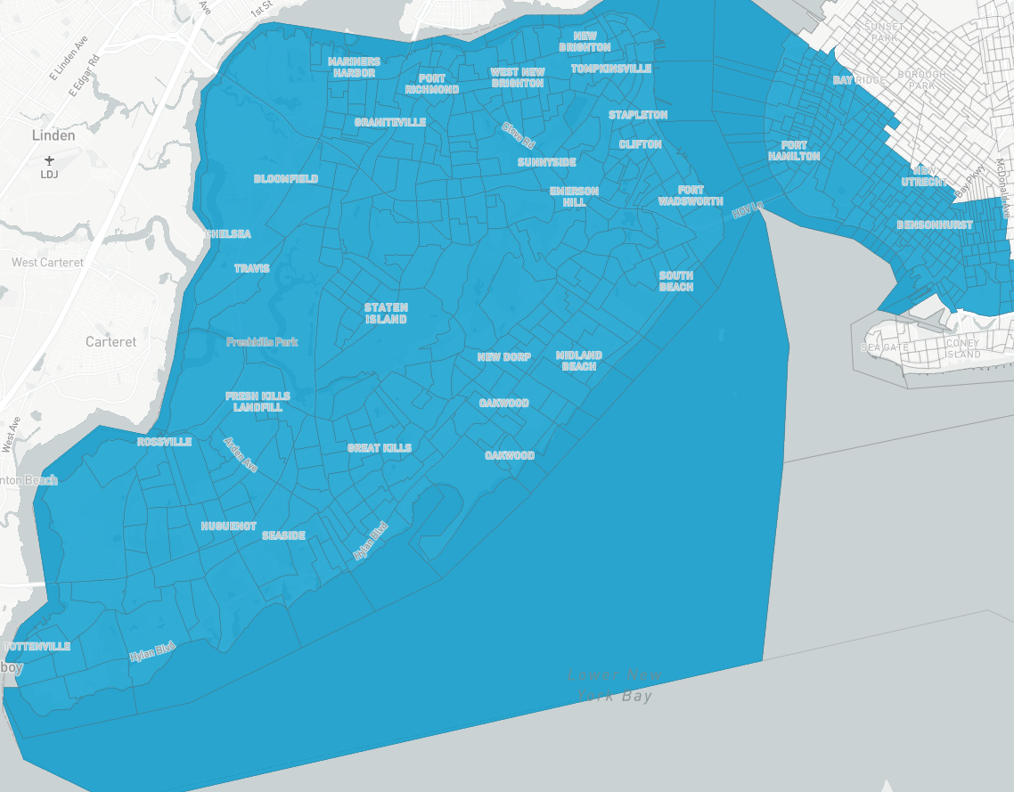

Proposed State Assembly District:

Current Bay Ridge “Land Bridge” – Congressional Districts

