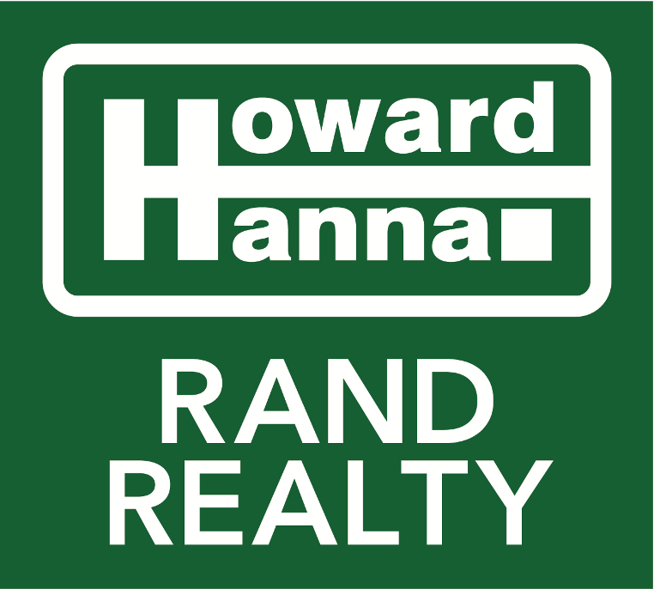

Joseph W. Rand
Chief Creative Officer
95 South Middletown Rd.
Nanuet, NY 10954
Mobile: 914-755-1561

November 8, 2021

VIA ELECTRONIC SUBMISSION

To the Redistricting Commission:

I am writing in my capacity as the Chief Creative Officer for Howard Hanna | Rand Realty, a real estate brokerage with about 20 offices in the Bronx, Westchester, and the Hudson Valley. I am also part-owner in the company, and have been for over 20 years. In full disclosure, I will also say that I am a Trustee in the Village of Nyack, where I have lived for the last 12 years.

I am writing to support efforts to maintain the 17th Congressional District’s inclusion of sections of both Westchester and Rockland, particularly the rivertowns on both sides of the Hudson River.

First, these are not two communities – they are one. As someone who has worked in the real estate brokerage business for over 20 years, with a major focus on this exact territory, I can tell you that this is really one unique community. The rivertowns share much in common: Hudson River access, architectural styles, political and cultural perspectives, and even property values. Although we are separated by a bridge, the actual distance between, say, Nyack and Tarrytown is only about 3 actual miles. And a significant percentage of people who live in Rockland commute to Westchester for work, either over the bridge or through one of the ferries that transport commuters every day.

Second, these communities share many of the same public policy challenges. As someone who is politically active, I can attest to the fact that residents on both sides of the river share the same challenges, many of which require attention from our congressional representatives. Of course, Rockland and Westchester generally share many of the same public policy concerns: property taxes, high cost of living, availability of affordable housing, quality schools, etc. But unlike the “inland” towns of Rockland and Westchester, the rivertowns on both sides of the river share unique but aligned concerns, such as for the health of the Hudson River and the maintenance of the waterfront areas.

Third, these communities provide necessary economic diversity. I believe it’s important for congressional representatives to cover municipalities that span multiple counties, because that gives them a more diverse perspective on their constituencies. For example, from a real estate perspective, someone who serves only the Westchester community will serve a much wealthier constituency: the current average sales price for single-family homes for the last full rolling year is $1,036,140 in Westchester, and $598,726 in Rockland. We need our congressional representative to be accountable to a wide range of constituents, not just service one narrow segment.

Essentially, if Rockland were cut off from Westchester, both communities would suffer. I would hate to see that happen, and I respectfully but fervently request that you maintain the geographically diverse nature of the 17th Congressional District.

My thanks to you for your service in this matter, and your courtesies.

Very truly yours,
