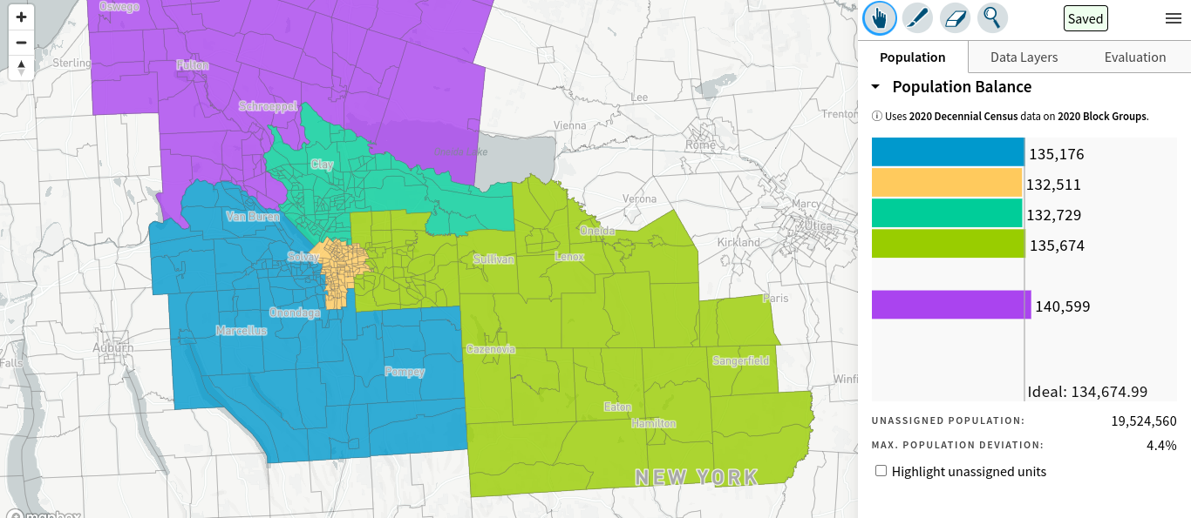

Description of Merit: Places City of Syracuse into a unified voice in which the excess population goes into the area with the most community ties (West End Suburbs with West End neighborhoods of Syracuse City have a very strong regional identity) Preserves Northern, Southern, Eastern, and Western Suburbs Identities as much as possible within realism of the need to conform to population and external district factors. Allows the entirety of Oswego County to remain united with the Town of Lysander as they have for at least a decade. This also creates an opportunity to restore a nearly-unified Madison County assembly district that was lost between the 2012-20 and the 2022 maps.

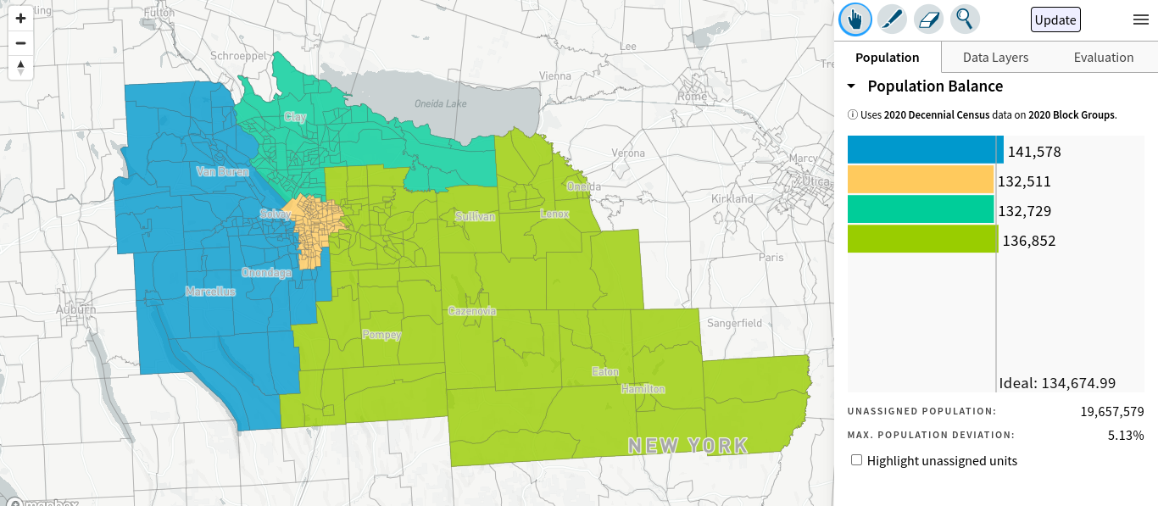

Description of Merit: Places City of Syracuse into a unified voice in which the excess population goes into the area with the most community ties (West End Suburbs with West End neighborhoods of Syracuse City have a very strong regional identity) Preserves Northern, Eastern, and Western Suburbs Identities as much as possible within realism of the need to conform to population and external district factors. Maintains a united Village of Baldwinsville and Greater Baldwinsville Identity that was split having Lysander in an Oswego district. This also creates an opportunity to restore a nearly-unified Madison County assembly district that was lost between the 2012-20 and the 2022 maps.

