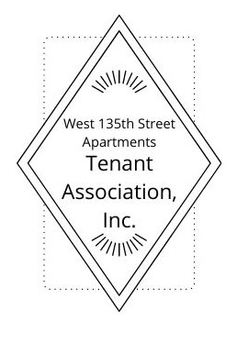
West 135th Street Apartments Tenant Association, Inc.
w135apts@gmail.com 917-294-6628
West 135th Street Apartments Tenant Association, Inc. - Home (west135thaptsta.org)
TA Executive Board
President
June Moses
1st Vice President
Ms. Paulette Nixon
2nd Vice President
Ms. LeVerne Taylor
3rd Vice President
Ms. Rebecca Cruz
Secretary
Ms. Rashetta Miller

Building Captains
107
Tanya Summers
123
Robert Armstrong
127
Ms. Roundtree
Ms. Joanne Sanchez
131
Ms. Erica Brewington
136
Ms. Shirley Ryan
139
Ms. LeVerne Taylor
145
Ms. Paulette Nixon
111, 115, 119
TA President

Good afternoon members of the NY State Independent Redistricting Commission and thank you for the opportunity to testify today. My name is June Moses, and I am speaking on behalf of The West 135th Street Apartments Tenant Association, Inc. I am president of the Association, and a resident of West 135th Street Apartments, 10 buildings housing 198 units ranging from 1 bedroom to 3 bedrooms on 135th Street between Lenox and Adam Clayton Powell Blvd. in Central Harlem. We are bordered by East Harlem and West Harlem, the Upper West Side and Washington Heights.
First, may I say that I thank the Center for Law and Social Justice and partners, for doing the hard part of making sure communities are not just aware of the redistricting process, but taught what our everyday citizens, like myself, need to know to understand and participate in the process.
Although we did not draw our own maps because we are very new and just learning the process, looking at the NY Independent Redistricting Commission’s proposed districts drawn for Central Harlem and the Unity Maps created by CLSJ, Latino Justice, and the Asian American Legal Defense and Education Fund, we must be in support of the Unity Maps. This is because the Unity maps keep whole communities of interest, those who live, shop, worship, go to school, etcetera together. Ensuring that communities of interest remain whole is important for the basic survival of any community, and the Unity Maps will ensure communities survival in an equitable way.
We appreciate the efforts of NYIRC. Their redistricting maps of Central Harlem are not that different from the current maps, but for State Senate District 30, it is proposed that it extend out of Manhattan and into the South Bronx. That doesn’t seem to be keeping communities of interest together, and for that reason, we support the Unity Maps.
Thank you for your time and attention.
June Moses

