Testimony Regarding Redistricting of Assembly Lines in Brooklyn 2023
Submitted to the New York Independent Redistricting Commission

By Raul Rothblatt
Resident of 44th Assembly District, 25th State Senate District,
10th Congressional District and 35th City Council District
rrothblatt@gmail.com
Brooklyn, NY 11217

Thank you for taking time to consider community input. Here is the link to my Distritr maps are here:
https://districtr.org/plan/178889

About me: I have been a community activist in Brooklyn since 2003 when I first got involved in the 57th Assembly District (AD) politics focusing on the Atlantic Yards and Downtown Brooklyn rezoning. Since then, I have worked as a staffer in the 20th State Senate District when it covered Brooklyn Community Boards 8, 9, 16, 17, 6 and 7. I then worked as a staffer in the 36th Council District covering Community Boards 3 and 8, and I am currently Director of Constituent Affairs in the 43rd Assembly District. I have spent 20 years promoting the Abolitionist history of Downtown Brooklyn, which covers Community Board 2. I am currently a Judicial Delegate and member of County Committee in the 44th AD, and I am active in attending 44th AD meetings.

I co-founded Prospect Heights Democrats for Reform, which filled a need when Prospect Heights was ignored part of the 57th Assembly District. I would say the neighborhood became more prominent in local elections in 2018 to 2021, but with the redistricting of 2022, it has again become a leftover thought: It’s at the extreme east of the 10th Congressional District and the extreme west of the 25th State Senate district, for instance. Because of the very odd proposed maps in the current Independent Redistricting Commission’s effort, I have revived the club simply for the purpose of addressing the problems of the current proposal.

I spent a few months trying to talk to as many stakeholders as possible, including District Leaders and club presidents based in the 44th, 52nd, 57th and 43rd Assembly Districts. I have also spoken as much as possible to elected officials and activists from the 55th and 56th Assembly Districts as well. I made an extensive effort to speak to as many current residents of Prospect Heights and organized both in person and online forums about redistricting.

My top priority: Keep Assembly lines simple, using major landmarks as anchor points. After many many conversations, I found that most people don’t understand our assembly lines, even in the highly engaged and high voter turnout neighborhood of Prospect Heights. I can understand the logic of putting Prospect Heights in the 52nd when looking at demographics. However, in order to have effective representation, I strongly believe Flatbush Avenue should be the boundary.

At the public hearing at Medgar Evers College on February 15, 2023, the IRC Commissioners frequently asked people why it was a problem if a community such as a NYHCA development was split. The gist of the commissioners’ questions was “Isn’t it better to have two representatives instead of one?” Having been an activist in Prospect Heights for many years, I can firmly state the answer is no. A bit of Prospect Heights has long been part of the 52nd, but consistently over decades with various representatives, the 52nd ignores the part in Prospect Heights. The weight of the district is elsewhere. In my many years, never have 52nd AD representatives attended a Community Board 8 meeting.

The current and the proposed lines cause only confusion among voters and potential voters.

Pushing Back Against the Commissioners: During the February 15th hearing, Commissioners frequently asked people testifying, roughly speaking, “Do you support the existing 2022 lines or the proposed IRC districts?” I thought this was the wrong way to frame the question. Many people came to testify about the 44th Assembly District, and all of them said they wanted to keep the 44th the way it was. However, after listening to people for four hours while attending the meeting in person, NOT ONE of the people testifying about the 44th mentioned Prospect Heights, which is currently in their district. I don’t think people are aware that Prospect Heights is in their district, and my neighborhood is ignored by the current District Leaders. Assembly Member Robert Carroll wrote in his testimony that Prospect Heights should be cut out of the 44th. I agree, but the point I am making here is that this whole discussion was undermined by the question of the Commissioners on whether the 2022 lines or 2023 proposal was better. Both are bad from a perspective of Prospect Heights.

My Second Priority: Respect the Community Board boundaries. The current proposal puts a bit of Brooklyn Community Board 8 into the 58th Assembly District. Speaking from personal experience, this makes it extremely difficult for staffers of state elected officials to attend the meetings for every part of their district. It would ensure that that part of both districts will get ignored. It doesn’t seem to improve the 58th AD in any way to include a tiny bit of CB8.

Assembly Districts lines change every 10 years, but Community Board (CB) districts very rarely change. Community Boards also develop their own culture. For instance, the African American and Chabad Jewish communities in CB8 (and CB9) have spent decades working to build collaborations and partnerships. While the census might consider these distinct groups, in reality they are a very unique “community of interest.” I truly hope the IRC to keep them together.

Please respect the input of Crown Heights North Association (CHNA). In my many conversations, the most thoughtful and thorough input came from CHNA. Their priority was to keep the area of Crown Heights from Rogers and Troy together in Crown Heights North. I mostly support this (more details below).

The 57th AD
My biggest problem with both the 2022 and the proposed 57th AD maps is that they ignore Flatbush Avenue. That should be the boundary between the 52nd AD and the 57th. Flatbush Avenue dates back to the Lenape era and predates European roads in Brooklyn. It remains a dividing line between neighborhoods and a reference point in many senses.

There are several housing developments that have long developed mutual alliances and communications. The Ingersoll, Walt Whitman and Farragut NYCHA developments are interconnected communities. While the Ebbets Field Apartment Complex might seem far away, in terms of the culture and politics of the 57th, they have historic connects that allow this constituency to keep its voice in a neighborhood that has become quite rich.

I would put the Brooklyn Botanic Gardens in the 57th Assembly District. It is so much closer to Crown Heights and Prospect Heights than to the 44th AD, which has long represented Prospect Park and neighborhoods to the west. The area just east of the Botanic Gardens has a large immigrant and African American community that would benefit from closer connections with the gardens, more so than the areas of Park Slope near Prospect Park, which is much richer and has access to more cultural institutions, including Prospect Park.

I am glad Empire Boulevard is kept as the southern boundary of the 57th. This is a natural division. I support this line in both the current and proposed maps.

The current IRC map moves the line between the 57th and the 43rd east to Nostrand. I want to strongly object to this. I currently work as Director of Constituent Affairs for the 43rd Assembly District, and our office is on the west side of Rogers and the north side of Empire, putting us in the 57th AD. Three of the last four District Offices for the 43rd AD were in this area between Rogers and Bedford in Crown Heights South between Empire and Eastern Parkway. The current and the last few assembly representatives have found this to be the heart of the 43rd and have chosen to put their offices there. The fourth of the last four offices was on Empire between Nostrand and Rogers Avenues. Instead, I support moving the easteryn boundary of the 57th to Bedford Avenue.

For simplicity’s sake, I would keep the boundary between the 57th and 43rd districts on Bedford between Eastern Parkway and Atlantic Avenue.

I am flexible about the line between the 57th and 56th north of Atlantic Avenue. Bedford would make sense as a major thoroughfare, but so is Nostrand. And the line between CB2 and CB3 is Classon, but putting the line there would probably make the population size of the 57th too small and the 56th too large.

In general I like to keep major streets as boundaries, but the exception to this is the area just north of Flushing Avenue between Classon and Bedford, give or take. The Satmar Jewish community has expanded here from the 50th AD, and it makes sense to keep them with the rest of their community. Between Navy Street and approximately Classon, the northern boundary of the 57th should clearly be Park Avenue. Because of the Brooklyn Queens Expressway, this has long been the northern edge of the historically Black community. Also, the waterfront areas have their own needs that are best represented by the 50th AD.

The northern boundary of the 57th AD should remain at York Street, in order to keep Farragut Houses together.

The 57th has historically been a majority African American assembly district. But it would be extremely difficult to keep it that way given how much this community has been pushed out. My proposal would make the 57th a little than one third African American and the white popular a little more than one third. It is still possible and important to keep the 56th and 43rd ADs majority African American.

The 43rd AD
I have spoken with Assembly Member Brian Cunningham about the exact lines, and I want to support the exact district he is proposing. I do believe it’s important to move the line between the 57th and 43rd east to Bedford Avenue, as I mentioned before. I also think it’s important to keep the Albany Houses in Crown Heights unified because they are too often ignored.
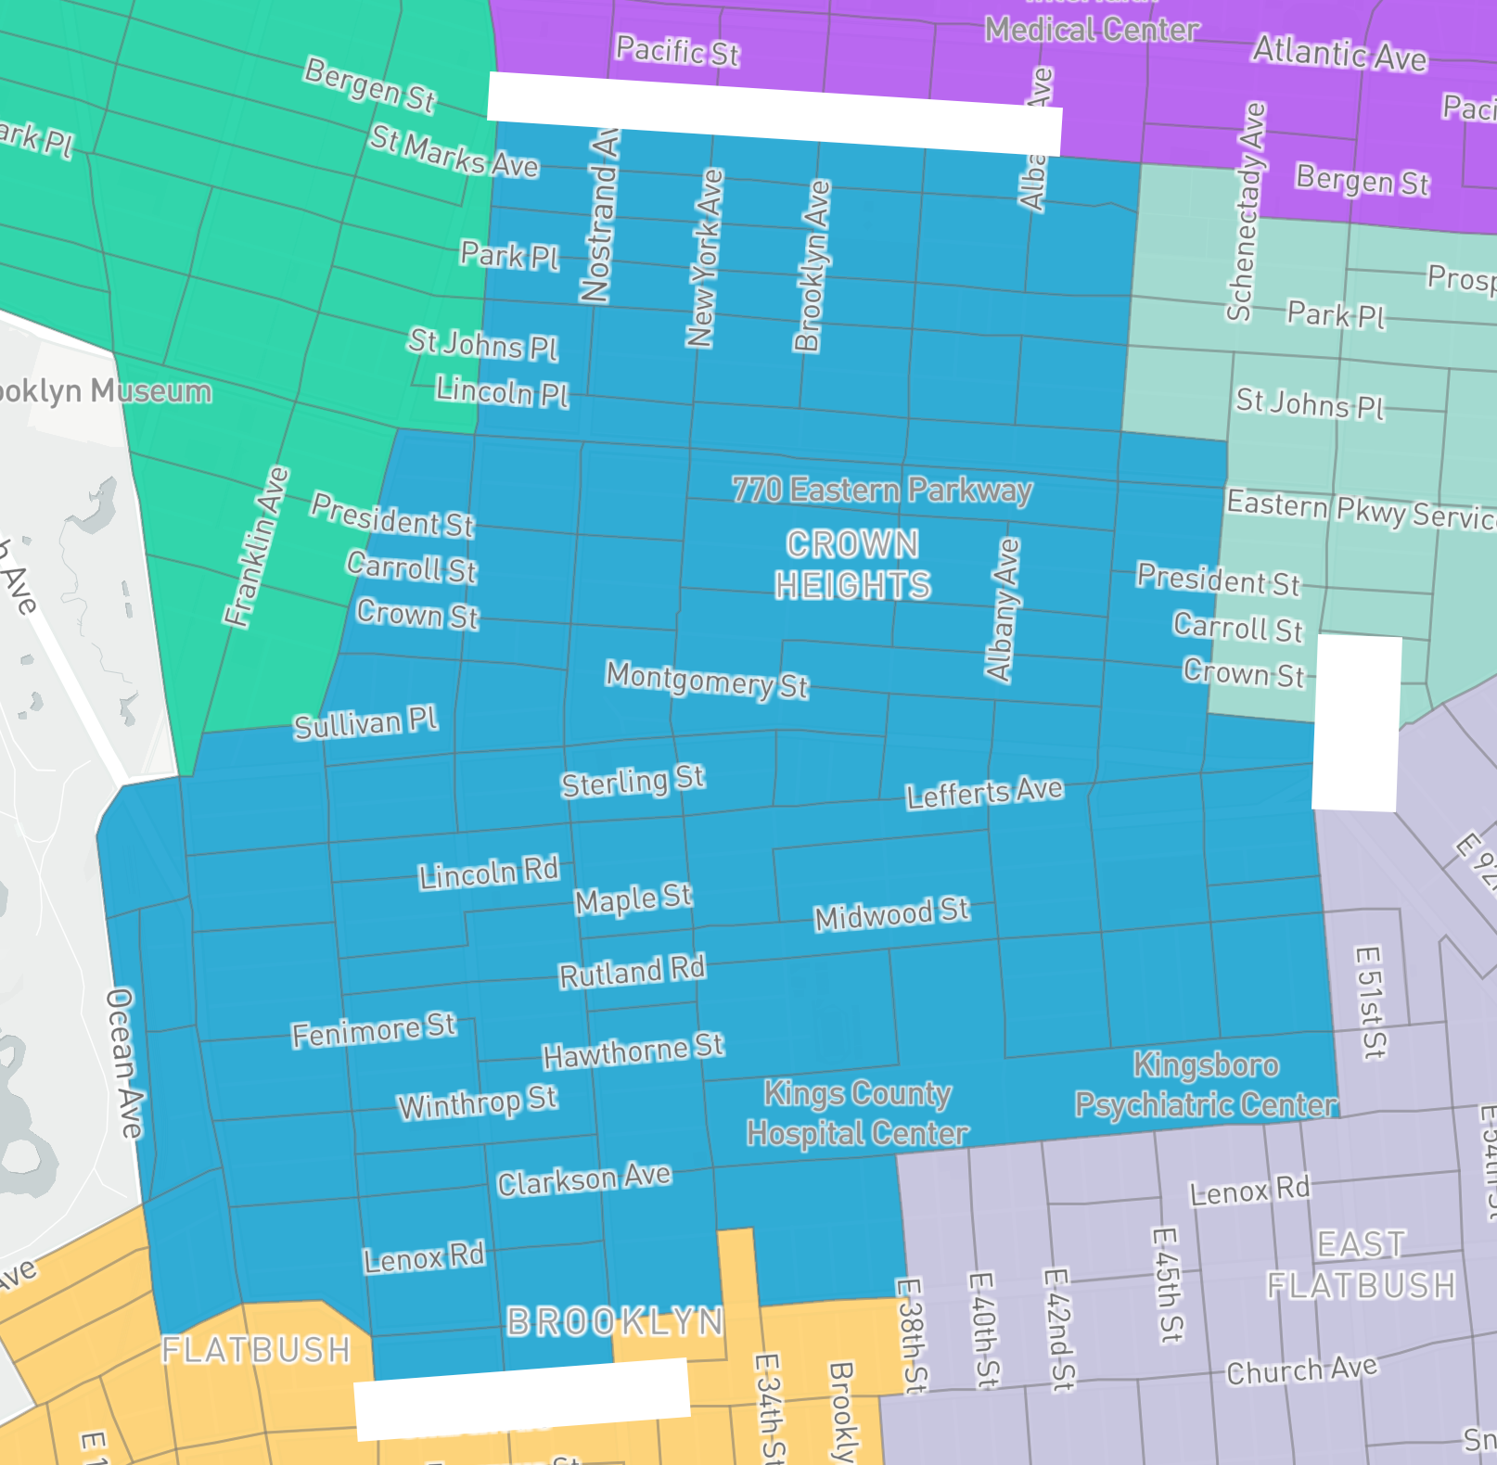

The 56th AD
I mentioned above that I deeply respect the opinion of Crown Heights North Association (CHNA). However, I do have a few disagreements with them. Several people testified at the Feb. 15 hearing from the 56th AD to keep the Weeksville Heritage Center in the 56th, and I agree. Its history is deeply tied to several cultural, religious and political organizations from Bed-Stuy/56th AD. For instance, Berean Baptist Church, Bridge Street AME, Concord Baptist and Weeksville have a unified history that dates to before the Civil War. I am a passionate defender of Brooklyn’s Abolitionist and Underground Railroad history, and all of those institutions were central to that history. They should be kept together.

I also am a big fan of Brownsville’s unique character. It is also a predominantly African American community, but it was Jewish until the mid-20th century. Its history is powerful and important, but it is quite distinct from the Bed-Stuy history. Just because they are both historically African American communities does not mean they are the same.

One of the goals of CHNA is to avoid cutting up CB8 into too many assembly districts. They would put the line between the 56th and the 43rd at Atlantic Avenue, as the draft IRC proposal does. However, Atlantic Avenue is facing huge development issues. The area between Bergen and Atlantic Avenue is zoned for industrial purposes, as is the area north of Atlantic. It deserves to have a comprehensive discussion, and it would be better to have one representative to truly understand and represent those complexities. Also, Fulton Street is the main commercial district of the 56th, and its economy is more tied to Bergen Street. I think there can be some creative solutions to re-envision this area, but it’s quite disconnected from the economy of Prospect Lefferts Gardens, represented by the 43rd. We have a chance to create new synergy between the Fulton Street commercial district and the industrial area between Atlantic and Bergen, so one Assembly representative would be much preferrable.

Broadway and Flushing Avenues are very clear dividing lines between neighborhoods. I would keep them, and for the most part the current 56th lines are excellent. The IRC proposal to bring the 56th north of Flushing would divide CB1 and would break up well-defined neighborhoods.

52nd AD
I’d like to find a polite words to describe the IRC proposal for the 52nd, but I have to say it’s nuts. First of all, it cuts up Fort Greene, a historically African American community. But the proposal also cuts up Carroll Gardens seemingly at random, and the Gowanus in a ways that make no sense to me. I have talked to as many people as possible, and not one person like the proposal. I would throw it out completely.

Also, the population density numbers for the 52nd are probably quite inaccurate. Downtown Brooklyn has had one of the most dramatic population growths of any neighborhood in the country in the last few years. I suspect that the population has increased since the maps were written, and even since I started writing these words. I have kept my Districtr numbers intentionally low for the 52nd for that reason.

44th AD
I read the testimony of Assembly Member Robert Carroll and a agree almost completely with him. I would want to keep the home of Lori Knipel in the 44th. She has been the Female District Leader for 30 years, and regardless of whether she remains in that position, her block has a long history as part of the 44th.

I also want to support the many activist who objected to moving the area around 36th Street into the 51st AD. That community has many connections to the rest of the 44th, and it would dilute the community of the 51st, which includes the Spanish speaking areas of Sunset Park and beyond.

I should note that our map uses 4th Avenue as a straight dividing line between the 44th and the 52nd. I consider this a good dividing line between Park Slope and Gowanus, as well as being a major thoroughfare.

55th AD
While Utica Avenue makes a good dividing line as an important transportation and commercial street, I feel it has been a bit neglected as a business district. I think it would help the community to move the line west to Schenectady or Troy.

In general, the existing 55th lines are better than the draft IRC proposal. Pennsylvania Avenue is a major dividing lines between neighborhoods, and I do not like extending it to the east. I don’t have strong feelings about the line between the 55th and 58th.

58th AD
Wow, the activists from the 58th were very passionate at the February 15, 2023 hearing. They preferred the current version of their district and the removal of the southern portion in the IRC draft maps. If people want to stay in their assembly district as much as they do, I hope the IRC listens to them.

I was also struck by the silences. Nobody advocated for bringing the 58th up to Eastern Parkway. Nobody seemed to notice that the IRC draft map would put Lincoln Terrace Park in the 58th. I believe it should stay in the 55th AD.

I am not that familiar with the granular details of the 58th, so while I put it on Districtr, this was mostly so I could submit better testimony for other districts.

42nd AD
I have included a draft map of the 42nd, but I want to emphasize that below Cortelyou I don’t know this district very well. Again, the focus of this testimony should be the 43rd, 44th, 52nd and 57th ADs. Nevertheless, I do think that it is important to keep the Caribbean majority of the 42nd.

Final Thoughts
I was very impressed with the patience of the IRC Commissioners. I do want to encourage even more communications. Please feel free to contact me and the other activists.

