My name is Katherine Walsh; I am born/raised here in Sunset Park. I am also on my local Community Board 7 Brooklyn and serve as the Transportation Chair. I am very active in my community and have extensive civic and political engagement including participating in local County Committee. I testified to the New York State Redistricting Commission virtually on Feb 15th. You can go to the website and choose “Part 3” 1:58 to view the recording of the testimony.

I submit testimony today on behalf of myself and my community. I request that you keep us in Assembly District 51 (Sunset Park) specifically the streets between 56th street and 54th street between 4th and 6th avenue in Sunset Park, Brooklyn together in the existing 2022 Assembly District Map. . The proposed map cuts out this section and moves into a new Assembly District 49th. Do not move us in Assembly District 49th. I ask you to please respond to what community members are asking for. Keep us in Assembly District 51.

I spoke with residents that live around on these blocks about this issue when it was first proposed in 2021. More than 35 neighbors already signed that they want to stay together in the 51st Assembly District. This is the second time I have come to testify about keeping us together. It was the same issue at that time that it was proposed we were removed but in the final maps we stayed in. We would like to stay in and I ask you to preserve the lines on 6th avenue.

Here in Sunset Park, we have experienced high rates of gentrification, and developments from all sides, we have high air pollution and lung cancer rates, we are dealing deluge of different challenges. It is important that we are unified in our elected representation to keep us together to work on these, and this needs to be reflected in the Assembly District Maps. I ask you to rise to your goals to keep neighborhoods, like Sunset Park, together, and specifically to keep these blocks under one unit in representation for the same assembly district in Sunset Park

Please keep 56th to 54th street between 4th avenue and 6th avenue in existing 2022 assembly plan map for Assembly District 51 – don’t move us into the 49th.

KEEP SUNSET PARK TOGETHER! New York State Redistricting Commission

New York is finalizing new district maps to change the Assembly district for the next ten years. Purple shows the proposed new district. Grey is our current map. The commission wants to move us into the Assembly District further east, associated with Borough Park and Bensonhurst. Our elected leaders can serve us better if Sunset Park stays in one district! Sign the petition to keep our Sunset Park community together.
THESE RESIDENTS SIGNED // ORIGINAL NAMES-SIGNATURES BELOW
First | Last | Address
Cesar | Zuniga | 434 55th street
Petra | Pena | 430 56th street
John | Cucci | 451 55th street
Mary and John | Murphy | 449 55th street
Strat | Muh | 435 55th street
Laura | Olin | 424 55th street
Yasko | Yoshida | 422 55th street
Angela | Aleman | 424 54th street
Jhodessa | Reimer | 428 54th street
Helene | Onserud | 428 54th street
Erik | Steyn | 428 54th street
Marun | Aleman | 424 54th street
Alice | Walsh | 452 54th street
Katherine | Walsh | 452 54th street
Viviane | Hays | 424 56th street
John | Milisenda | 424 56th street
Natalie | Reubens | 424 56th street
Joseph and Lisa | Estrella | 432 56th street

Josiah | Estrella | 432 56th street
Michael | Sierra | 559 56th street
Jessica | Sierra | 559 56th street
Wanda | Sierra | 559 56th street
Tanya | Varges | 563 52nd street
Judith | Rosario | 563 52nd street
Gladys | Cruz | 234 54th street
Damarys | Villaneuva | 563 52nd street
Nancy | Acevedo | 563 52nd street
Karen | Moore | 563 52nd street
Madison | Moore | 563 52nd street
Matthew | Sierra | 559 56th street
Samuel | Sierra Jr. | 559 56th street
Samuel | Sierra Sr. | 559 56th street
David | Santiago | 559 56th street
Victor | Perez | 479 56th street
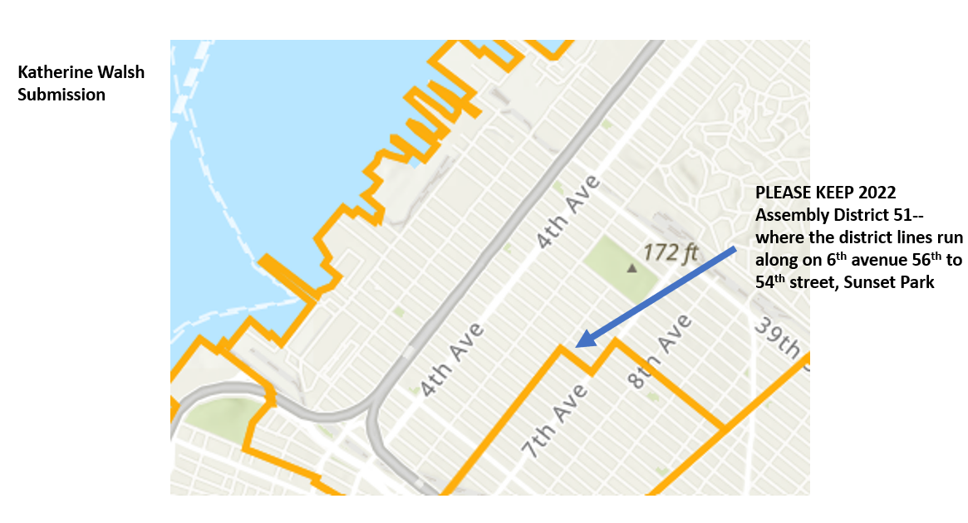
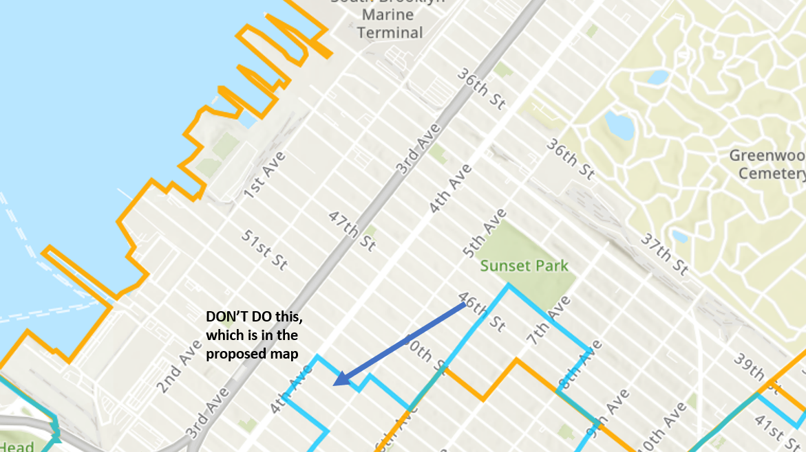
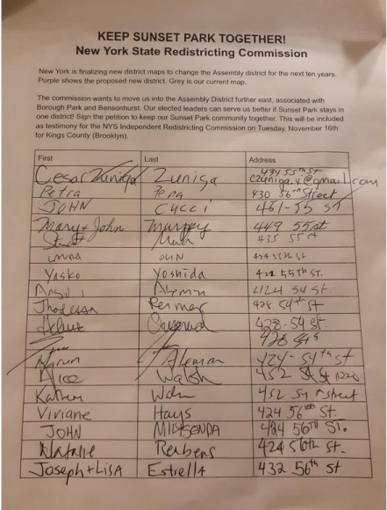
MAPS SUBMITTED AS PART OF THE TESTIMONY

