My name is Katherine (Katie) Walsh and I live in Assembly District 51. I testified to the New York State Independent Redistricting Commission virtually on November 16th. You can go to the website and choose “Part 3” https://bit.ly/testimonyWalsh to view the recording of the testimony.

I am providing this additional written testimony for three reasons.

First, to submit the names of residents in the affected area who signed on to voice their desire to stay in the Sunset Park Assembly District. We are asking you to keep these blocks, from 53rd to 57th Street between 4th and 6th Avenue, in the Sunset Park assembly district. The second reason is to provide written testimony, which I provided virtually, so this is available for the public record (see below.)

My third reason to submit additional testimony is to raise a concern which came about during my virtual testimony and the responses in real-time from the commissioners. I wanted to draw attention to the fact that I am a former Democratic candidate for the 51st Assembly District (Katherine Walsh for New York State Assembly District 51, June 2020 primary). The proposed Democratic “letters” lines to the map which take this ‘bite’ out of Sunset Park is specifically in the area where I am currently registered to vote/live. If the proposed ‘Names’ map is kept as is, this would remove me from the Assembly District. Again, this is the same Assembly District where I recently ran for state-level office.

During the testimony, the commissioners did not provide reasons for why this ‘bite’ was taken out of the Assembly District ‘Letters’ map. I’d like to assume a good-faith effort in the development of the New York State independent redistricting maps. It is my hope that transparency, accountability and equity are a cornerstone guiding these decisions. After my virtual testimony, the commissioners said that they “weren’t sure why they had done this,” and then pre-supposed it was because of population changes. However, these same maps also expand to include whole new parts of Bay Ridge. I raised this concern in my follow-up in the Question and Answer period— Why are you proposing to take ‘bites’ out of Sunset Park, while expanding to include Bay Ridge? The Commissioner was not able to provide a response to this.

As I submit the testimony below that I provided publicly, I just want to raise these concerns and ask for you to keep Sunset Park from 53rd and 57th between 4th and 6th avenue in Sunset Park, Brooklyn in the same Assembly District.

Testimony provided by Katherine (Katie) Walsh on November 16th, 2021.

I am here to testify about some of the proposed changes for the Democratic ‘Letters’ map for Assembly District 51. I live here in Sunset Park; we are a predominantly immigrant, working class, waterfront community and our current Assembly lines go from Red Hook through Sunset Park to a small part of Bay Ridge.

I am testifying today to ask you to please keep the Sunset Park community together. In the proposed “Letters” Assembly District map, there are several places where you propose to take ‘bites’ out of Sunset Park. And understanding it is part of your goals to keep communities of interest together and think of the historical context of the neighborhood. I ask you, please don’t break up the neighborhood.

One specific area I am talking about is where I am a neighbor between 53rd and 57th between 4th and 6th avenue. I’m also on the Democratic County Committee where I serve on Election District 32. I spoke with residents that live around on these blocks that are proposed to be moved out of the Sunset Park Assembly District. I have included below the original signatures and names of more than 35 neighbors from Sunset Park who want to stay together in the Sunset Park Assembly District.

It is essential that you keep Sunset Park neighbors together as we have experienced high rates of gentrification, and developments from all sides, we have high air pollution and lung cancer rates, we are dealing deluge of different challenges, and so it is important that our elected representation keeps us together to work on these, and this needs to be reflected in the Assembly District Maps.

I ask you to rise to your goals to keep neighborhoods, like Sunset Park, together, and specifically to keep these blocks under one unit in representation for the same assembly district in Sunset Park from 53rd and 57th between 4th and 6th avenue in Sunset Park, Brooklyn.

MAPS SHOWN DURING THE TESTIMONY
During my testimony, I showed the old and proposed district maps for the “Letters” map made by the Democrats. I asked the commissioners to keep Sunset Park residents together – specifically our blocks. I said that our elected leaders can serve us better if we stay together.
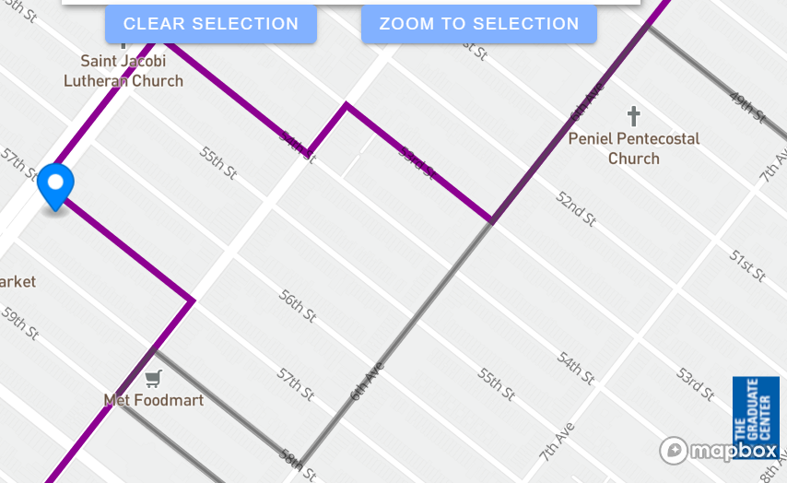
This is a close-up view. The gray line shows the ‘old’ map where we are included with the Sunset Park Assembly District. The purple lines shows the new district – taking us out of Sunset Park
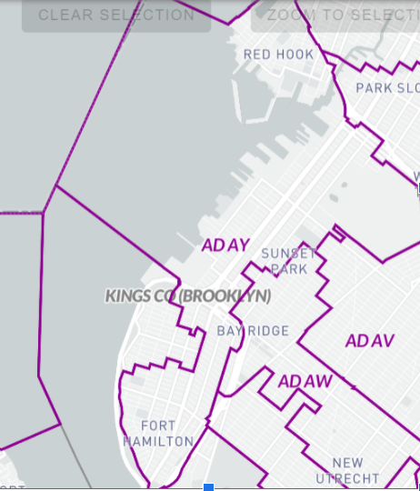
This is the “bite” that removes us out of the Assembly District with Sunset Park and puts us with Borough Park and Bensonhurst
KEEP SUNSET PARK TOGETHER!
New York State Redistricting Commission

New York is finalizing new district maps to change the Assembly district for the next ten years. Purple shows the proposed new district. Grey is our current map.

The commission wants to move us into the Assembly District further east, associated with Borough Park and Bensonhurst. Our elected leaders can serve us better if Sunset Park stays in one district! Sign the petition to keep our Sunset Park community together. This will be included as testimony for the NYS Independent Redistricting Commission on Tuesday, November 16th for Kings County (Brooklyn).

THESE RESIDENTS SIGNED // ORIGINAL NAMES-SIGNATURES BELOW

First | Last | Address
Cesar | Zuniga | 434 55th street
Petra | Pena | 430 56th street
John | Cucci | 451 55th street
Mary and John | Murphy | 449 55th street
Strat | Muh | 435 55th street
Laura | Olin | 424 55th street
Yasko | Yoshida | 422 55th street
Angela | Aleman | 424 54th street
Jhodessa | Reimer | 428 54th street
Helene | Onserud | 428 54th street
Erik | Steyn | 428 54th street
Marun | Aleman | 424 54th street
Alice | Walsh | 452 54th street
Katherine | Walsh | 452 54th street
Viviane | Hays | 424 56th street
John | Milisenda | 424 56th street
Natalie | Reubens | 424 56th street
Joseph and Lisa | Estrella | 432 56th street

Josiah | Estrella | 432 56th street
Michael | Sierra | 559 56th street
Jessica | Sierra | 559 56th street
Wanda | Sierra | 559 56th street
Tanya | Varges | 563 52nd street
Judith | Rosario | 563 52nd street
Gladys | Cruz | 234 54th street
Damarys | Villaneuva | 563 52nd street
Nancy | Acevedo | 563 52nd street
Karen | Moore | 563 52nd street
Madison | Moore | 563 52nd street
Matthew | Sierra | 559 56th street
Samuel | Sierra Jr. | 559 56th street
Samuel | Sierra Sr. | 559 56th street
David | Santiago | 559 56th street
Victor | Perez | 479 56th street

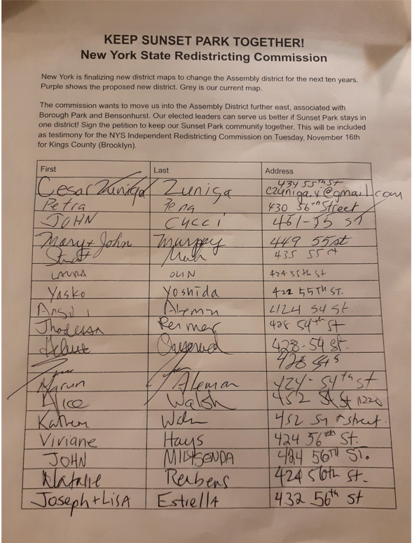
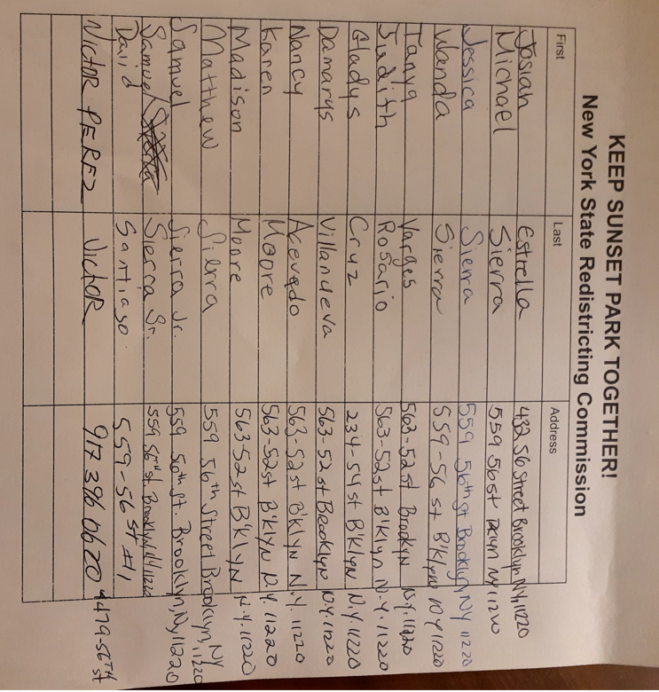

MAPS SUBMITTED AS PART OF THE TESTIMONY

