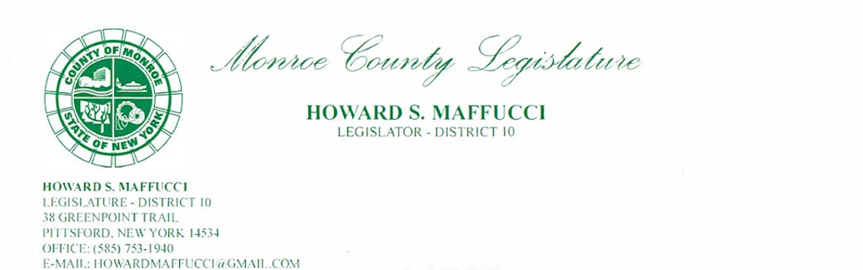

January 19, 2023
Independent Redistricting Commission
Re: 135th Assembly District Redistricting
Commissioners:
As the current county legislator representing District 10, I am writing to provide logical support to keep the 135th Assembly District in its current form. County Legislative District 10 includes a large area of Pittsford, a somewhat smaller part of East Rochester, and a tiny part of the Town of Brighton.
The current 135th Assembly District provides its residents with a compact district that provides representation consistently and logically to communities of similar and overlapping interests.
The current 135th Assembly District has four villages essential to their larger towns. Pittsford, Fairport, East Rochester, and Honeoye Falls villages have unique similarities that provide a logical reason to keep their assembly representation together. That representation is critical to support their needs around infrastructure, transportation, education, and other government functions.
As a former high school principal, superintendent of schools in the East Rochester School District, and teacher/coach in Pittsford, I like to keep issues simple. In this case, there is significant support and logic to keep the 135th Assembly as it is.
Thank you for the opportunity to provide written testimony in support of the current 135th Assembly District.
Should you need additional information from me, please feel free to contact me by phone or email.
Thank you again for accepting my written testimony.
Sincerely,
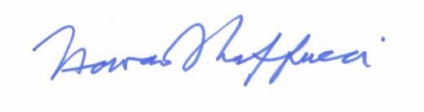
Howard Maffucci
Monroe County Legislator – LD 10
howardmaffucci@gmail.com
585-750-3116

