January 25, 2023

Ken Jenkins
Chair, New York State Independent Redistricting Commission
Independent Redistricting Commission
250 Broadway, 22nd Floor
New York, NY 10007

Dear Chair Jenkins:

I am writing on behalf of the people of the 58th Assembly District, many of which I represent as the Member of the City Council from the 46th District.

Since its creation following the 1990 Census, the 58th Assembly District has covered the area of Canarsie, north of Rockaway Parkway. However, the initial proposal further fractures Canarsie into three separate Assembly Districts (58, 59, & 60) creating a myriad of issues for residents of the neighborhood and leaving the 58th Assembly District to cover just the most far western part of our community. The splitting up of Canarsie continues to deny residents of the fair, effective, and consolidated representation they deserve in the New York State Assembly. A fragmented Canarsie will disrupt city services, and make funding for programs, infrastructure, and other vital initiatives very difficult. Canarsie is a community with unique needs, and several active and vibrant community and civic groups, who are comprised by people who are fully invested in doing what is best for our beloved neighborhood.

I ask that the 58th Assembly District solely cover the area north of Rockaway Parkway to the East 108th Street border, with the 59th Assembly District covering the area to the south. Keeping Canarsie within two Assembly Districts will allow residents to properly advocate for the needs of our beloved community.

I thank you for your thoughtful consideration and urge you to act to keep Canarsie within just two Assembly Districts.

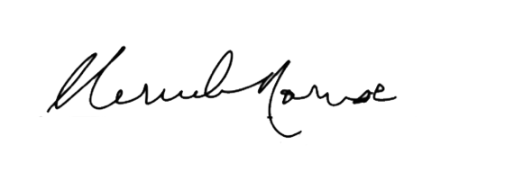
Sincerely,

Mercedes Narcisse
Member of the City Council

