To: NYS Independent Redistricting Commission
Date: November 17, 2021
RE: Proposed map for current NYCD 16

My name is Dr. Rosa Rivera-McCutchen. I am a resident of New Rochelle in what is currently NY congressional district 16. Below, I combine my comments from both the in-person session in White Plains and the Zoom portion in Brooklyn. I also include in a copy of what I refer to as the “Lisa Burton map” in this written testimony.

I am an associate professor of school and district leadership at Lehman College where a significant number of my students, who are educators seeking their leadership credentials, work in schools that are located in NY16. Specifically, they work in schools located in Baychester, Wakefield, Edenwald, Co-Op City, Mt. Vernon, Yonkers, New Rochelle and Mamaroneck. My 20 plus years of experience as an education researcher and practitioner has taught me that that the educational justice issues that face the schools in the North Bronx are similar to their Southern Westchester counterparts of Mt. Vernon, Yonkers, New Rochelle and, even in Mamaroneck and Pelham. These communities of interests should be kept together in any new map that is drawn.

Drawing a line separating these communities greatly weakens any elected leader’s leverage in advocating on behalf of the schools that have common needs. The schools on both sides of the boarder separating the Northern Bronx and Southern Westchester are more similar than they are different, in terms of demographics and resource needs. This is especially true for students who have special needs, children who are newcomers and emergent English language learners, and well as other historically marginalized student groups. When these communities are together, as they currently are, their voices cannot be diluted and, as result, advocacy around educational justice issues can have a profound impact.

The Commission charged me and others with drawing an alternate map with proposed boundaries. In response to that charge, my fellow New Rochellian, Lisa Burton, proposed a map that accounts for the population growth in the five boroughs, while taking into account the importance of keeping communities like New Rochelle intact (see below) as a community of interest. This proposed map also keeps the demographic data as close to the current map as possible, unlike other maps proposed in prior testimonies.

Characteristics of the “Lisa Burton Map”

 | Blue District | Green District
Population | 777,552 | 777,309
White | 40% | 61%
Black | 30% | 11%
Hispanic | 26% | 20%
Asian | 7% | 7%

The proposed “Lisa Burton Map” would keep the northern Bronx areas of Co-op City, Edenwald, Baychester, Wakefield & Williamsbridge. In addition, the following Westchester area communities would also be included:

Yonkers (with the exception of a small portion)
Mt. Vernon
Hastings-on-Hudson
Ardsley
Pelham
New Rochelle
Scarsdale
Mamaroneck
Larchmont
Rye
Harrison
Portchester
Purchase
Mt Kisco
Bedford
Katonah
Pound Ridge
North Salem

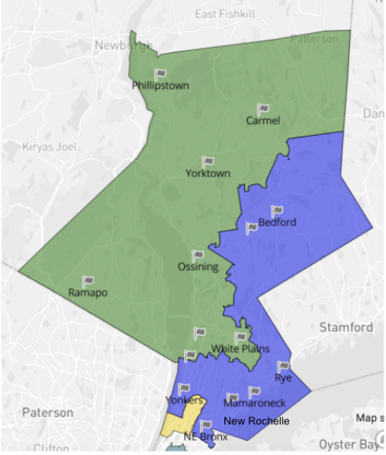

Respectfully submitted by Dr. Rosa L. Rivera-McCutchen

