The City of Poughkeepsie
New York
Marc S. Nelson
City Administrator
Robert G. Rolison
Mayor

January 10, 2022

Dear New York State Independent Redistricting Commission,
I am writing to you today in regard to your important work and as the elected City of Poughkeepsie Mayor in the 41st Senate District.
I recognize the complex choices you are all facing in your endeavors, and I want to express how critically important I believe it is to keep the City of Poughkeepsie -- the Dutchess County seat of government -- with the other municipalities in Dutchess County as you make decisions on Senate districts.
The public is often confused by the various levels of government and, at times, understandably expresses frustration with why representative lines are not more in sync with geographical ones or with other government boundaries.
Undoubtedly, having all layers of government working more effectively to deliver services through unified, rather than patchwork, efforts should be of paramount concern and interest for the public good.
For these reasons, I ask you not to sever the county into different Senate districts, and I surely believe the county seat should, at the very least, be located in the Senate district containing the majority of municipalities in Dutchess County.
Any other decision would defy common sense, needlessly cause public confusion and make it more difficult and cumbersome for state representatives to coordinate efforts with county and municipal leaders on the ground.
I trust you will take these points into consideration. Please feel free to contact me at (845) 451-4073 or mayor@cityofpoughkeepsie.com if you have any questions.

Sincerely,

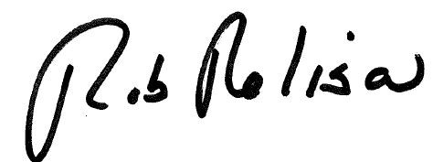

Mayor Robert G. Rolison

Municipal Building • 62 Civic Center Plaza • Poughkeepsie, NY 12601 • 845.451.4073 • 845.451.4201

