I have constructed a map more in line with the existing communities and relationships that exist on Long Island, and Suffolk more specifically, than the draft map produced by the commission. A detailed breakdown can be made available if interested, but the broad details can be seen in the attached screenshot.
Broadly, however: This map is more in line with the ones used by the Special Master for the State Senate and adjusts elsewhere for obvious population based reasons.
Fewer districts cross town lines than in the commission draft and where they do it is for a clear community of interest. It also reduces the number of cross-county districts from two to one in the previous map used in the 2022 election.
The theme of my proposed map is using human and natural themes and existing communities to form districts. To summarize in order:
AD1 changes little, shifting some Brookhaven territory around and picking up some of Riverhead but forming a more natural division between the "downtown" of the Riverhead community and the section of the town further west that has more in common with north Brookhaven. As an advantage, my map makes it possible to drive around AD1 without resorting to a ferry!
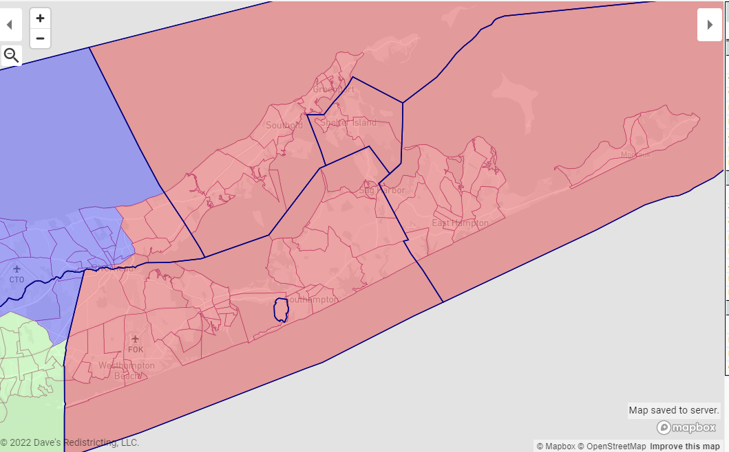

AD2 also changes little, centering somewhat further west and adjusting its southern border but the composition of the district remains largely the same.
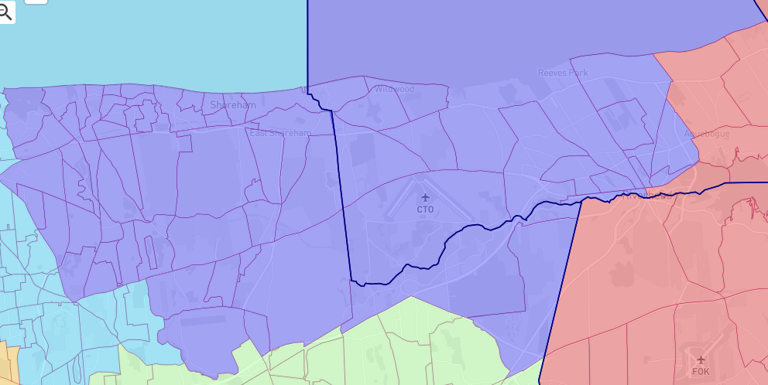
AD3 also changes relatively little, although it sheds Bellport Village and some of central Brookhaven for more of eastern Brookhaven, including most of the Eastport-South Manor community.
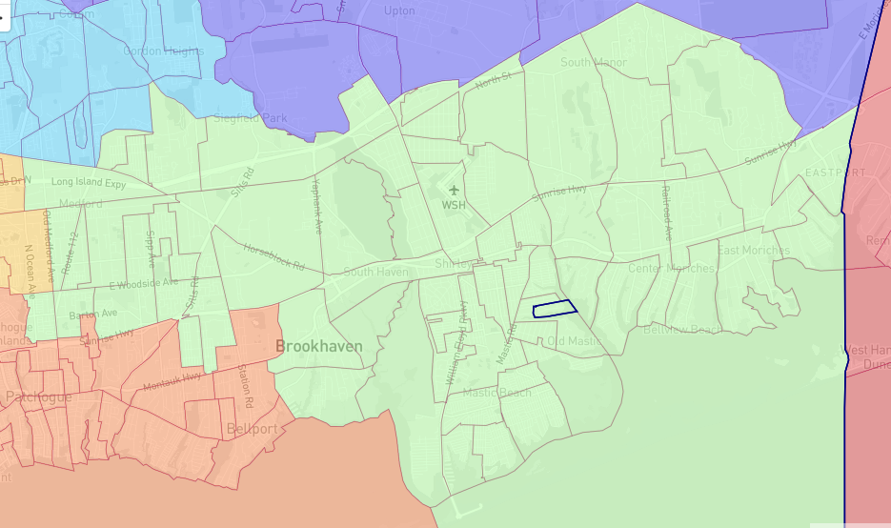
AD4 changes very little, retaining the connection desired by Gordon Heights residents to stay connected to the Three Villages community. Some EDs on the periphery are adjusted primarily for population balance.
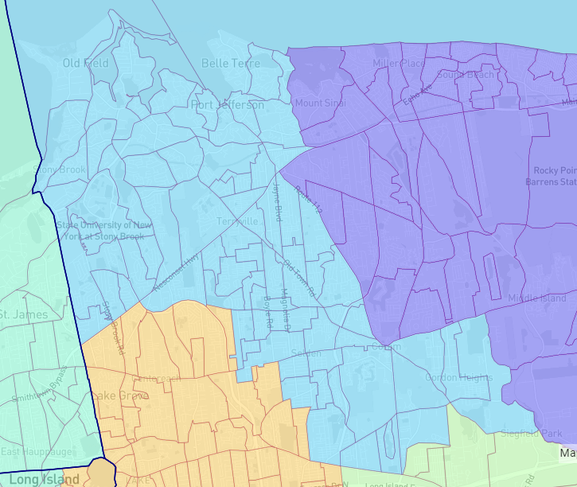

AD5 becomes, truly, a Lake Ronkonkoma community of interest, straddling Brookhaven and Islip and containing Macarthur Airport.
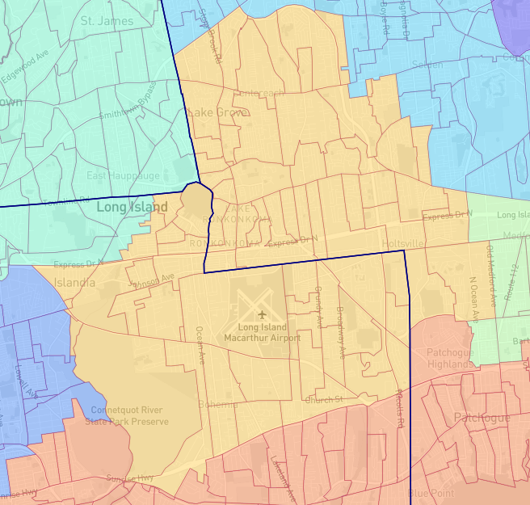
AD6 remains Suffolk's Hispanic majority district. In this proposal, Central Islip remains intact, not split. It is a community that has frequently been split as a matter of convenience when redistricting occurs (see the current Town of Islip map) and it is unfairly discriminatory to the minority-majority population of the hamlet to split them and their interests. This keeps them with their current district partners in East Brentwood and the Assemblyman who has ably represented them the last decade. The commission's proposal, which splits CI in two, adds some but not all of the Hauppauge school district, and extends AD7 up to Suffolk Avenue, does not accurately reflect the characters of these communities. Moreover, the currently map that gives AD7 the Connetquot River State Park splits another common community that is better reflected by being unified with AD5. Both of these are rectified in my draft map.
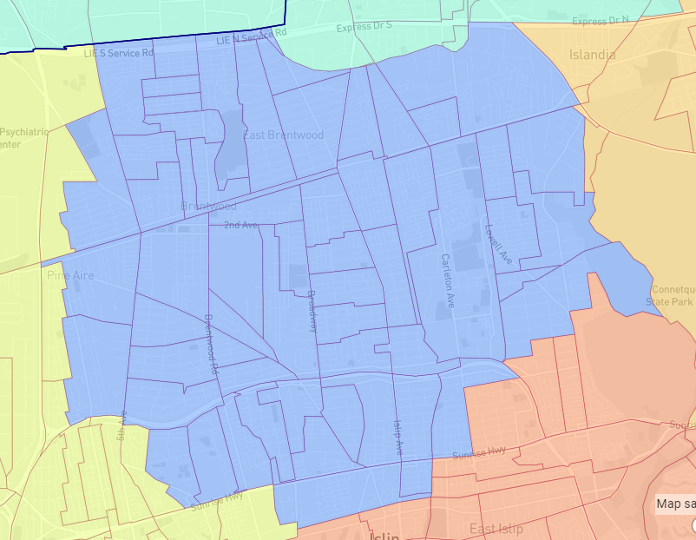

AD7 then, properly, becomes a Great South Bay community of interest, spanning the major downtowns of the central South Shore, which share a great deal in terms of temperament and interests. The district functionally stretches from the downtown of Bay Shore to the downtown of Bellport Village and gives those communities, with much in common, a single voice to represent their common interests.
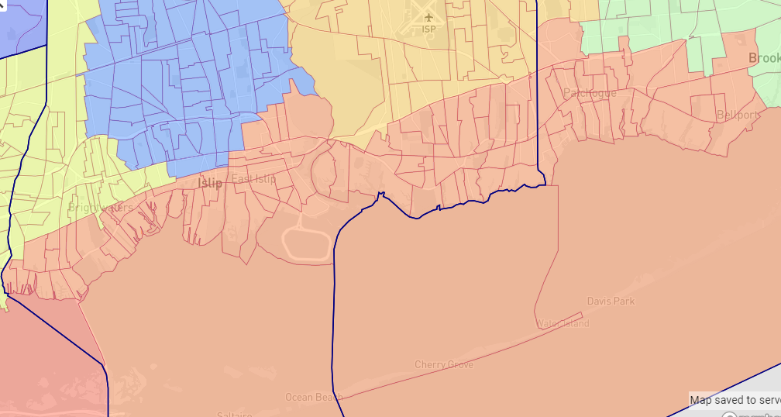
AD8 changes very little. It is primarily a Smithtown centered district, dipping into Islip for the hamlet of Hauppauge, which as a school district straddles both towns. In this regard a community is kept together with a single representative.
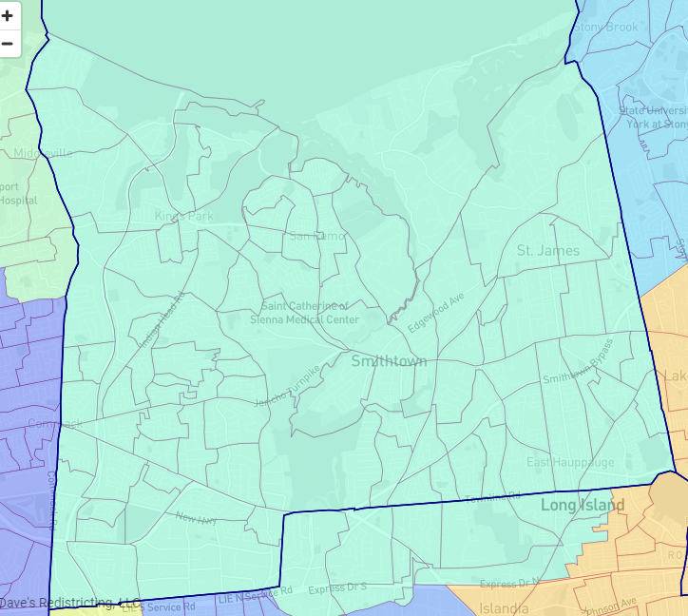
AD9 changes significantly, undoing the eyesore of using Fire Island to connect two incredibly different communities. This proposal unifies the communities of Baywood, North Bay Shore, and West Bay Shore in Islip with very similar communities across town lines in Deer Park, North Babylon, and West Babylon. By the end of the decade it is possible this district could become, if not minority majority, then certainly a minority opportunity district, increasing the variety of representation that Suffolk County sends to Albany. It also has similar socioeconomic characteristics that make a union a significant improvement on the current AD9.
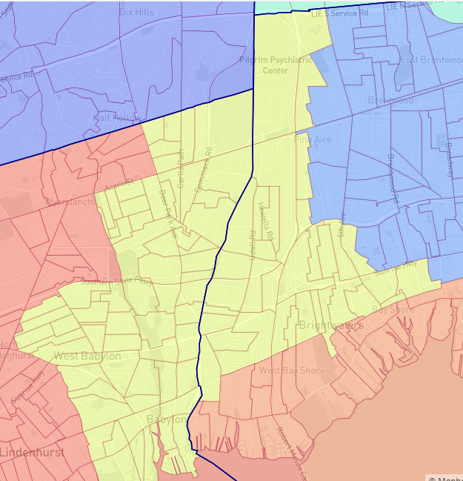
AD10 is the core of Huntington town, going from the border with Babylon up to a line roughly along Pulaski Road. This road is the functional division in some ways between the traditionally suburban section of Huntington and the more "downtown" coastal centers of Greenlawn, Huntington Village, and so forth.
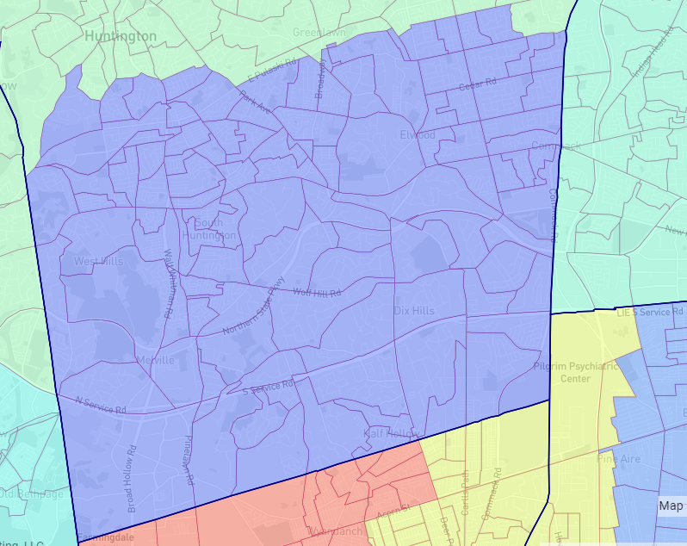
AD11 becomes more compact, shedding entirely any territory outside the town of Babylon, while staying a minority-majority district.
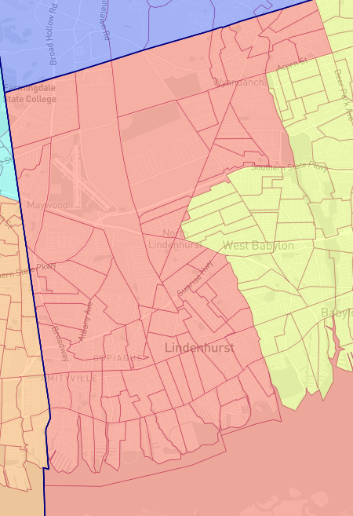

Finally, AD12, instead of stretching from the north shore of Huntington through Babylon and Islip almost to the Great South Bay, becomes a North Shore community of interest by combining the villages of Huntington town to the similar communities of northern Oyster Bay in Nassau.
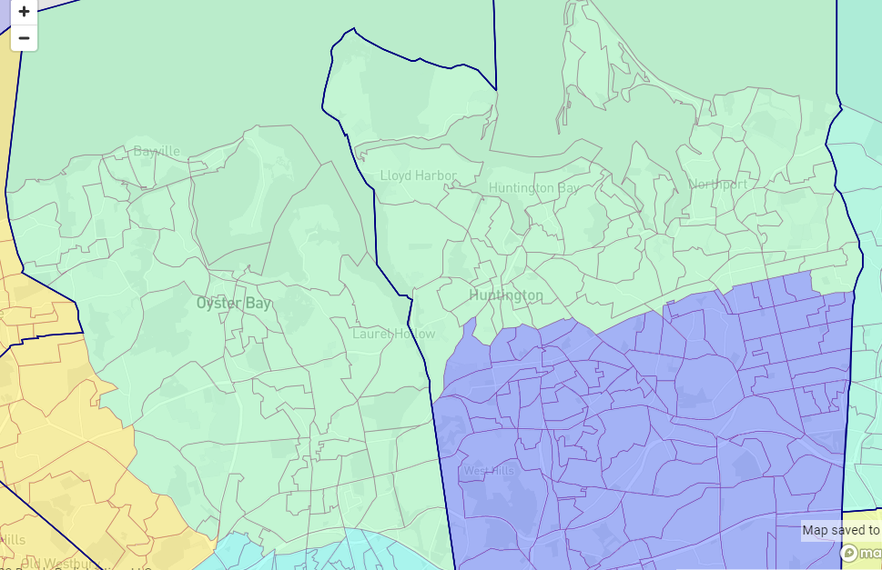
A link to the Dave's file used to construct this map can be found here. Please note the map only consists of Suffolk and Nassau and the Nassau section was more primarily used to ensure my districts were sized properly rather than a serious attempt to redraw the map of a community I do not live in. Ideally some of these lines would be adjusted-for example, in North Bellport, an effort to split some districts that straddle Sunrise Highway would produce maps that more accurately reflect conditions on the ground-but I'm not quite technically savvy enough for that. Another spot would be the small section of the proposed AD9 that darts south of Union Blvd, which would make more sense in AD7.
https://davesredistricting.org/join/58895d73-4f98-4834-a32b-56544e113441

