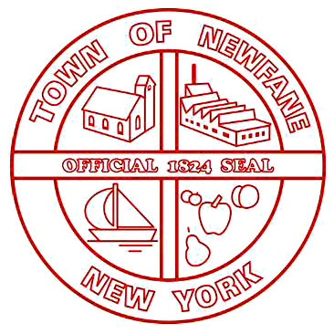
SUPERVISOR
716-778-8531

TOWN CLERK
716-778-8822
FAX 716-638-4183

ASSESSOR
716-778-8827

TAX COLLECTOR
716-778-6052

BUILDING INSPECTOR
716-778-5947

WATER/SEWER
716-778-8132

TOWN OF NEWFANE
2737 Main Street
Newfane, New York 14108

FAX 716-638-4261
JUSTICE COURT
2896 Transit Road
Newfane, New York 14108
716-778-9292

HIGHWAY
716-778-8844

WATER/SEWER
MAINTENANCE
716-778-8587

6176 McKee Street
Newfane, New York 14108

TDD 1-800-662-1220

Monday, January 9, 2023
5:00 PM
Buffalo Public Hearing
Location: Buffalo State College (SUNY)
Burchfield Penney Art Center 1300 Elmwood Avenue Buffalo, New York 14222

Dear Chairman Imamura and Members of the New York Independent Redistricting Commission:

As the Town Supervisors of the Lakeshore / Agriculture Corridor communities in northeastern Niagara County, we are writing to express our concern of any redistricting proposal that would separate our respective towns of Newfane, Somerset, Wilson, Royalton and Hartland into different Assembly Districts.
Over the past decade, our communities have shared similar experiences in relation to controversial intrusive energy siting projects, protecting agriculture interests, promoting continued agri-tourism such as the Niagara Wine Trail, and improving infrastructure initiatives. Our communities also have similar socio-economic demographics and share school districts that work cooperatively to advocate for the needs of students and families. Three of our communities also are directly on the Lake Ontario shoreline and have dealt cooperatively on flooding and shoreline redevelopment and refortification (REDI Initiative).
Our communities are truly an area of common interest and should be represented by one voice in the State Assembly. Through these issues and mutual experiences, we have relied heavily on having one Assembly representative at a time to assist, advocate, and deliver resources and has truly permitted us to work together with our State Official to handle our similar matters of concern.

We respectfully submit to the Members of the New York Independent Redistricting Commission for the record, our shared testimony regarding the importance of keeping the Lakeshore / Agriculture Corridor in northeastern Niagara County in intact in whole with the Towns of Newfane, Somerset, Wilson, Royalton and Hartland under the same Assembly Representative when redrawing district lines for the next 10 years.

Your consideration is sincerely appreciated.

Sincerely,

Doyal Phillips - Supervisor, Wilson
John Syracuse - Supervisor, Newfane
Jeff Deward - Supervisor, Somerset
W. Ross Annable - Supervisor, Hartland
Dan Bragg - Supervisor, Royalton

