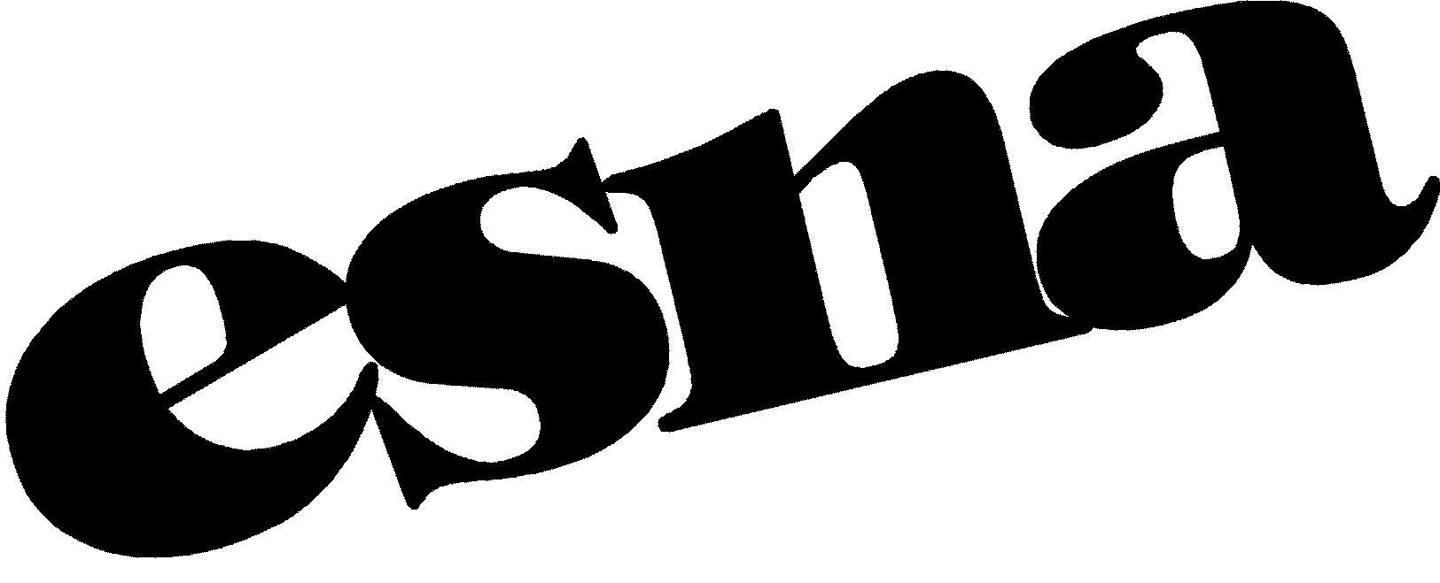

Not-for-Profit Corpor
east sixties neighborhood association, inc.
P O Box 1855
New York, NY 10021-0048
Tel: 212-713-5826 • www.esna-nyc.net • info@esna-nyc.net

November 8, 2021

VIA EMAIL: submissions@nyirc.gov

To Whom It May Concern:

My name is Barry Schneider and I have been a resident of the 12th Congressional District for more than 50 years. I am President of the East Sixties Neighborhood Association, Chairman Emeritus of Manhattan Community Board 8's and currently co-chair of the Parks and Waterfront Committee.

Throughout the COVID19 crisis, many of the small businesses who are ESNA members were gravely impacted. As ESNA’s President, it is critical that this area is represented by a member of Congress who will support small businesses and ensure their full revitalization just as our current representative has done. And as the co-chair of Manhattan Community Board 8's Parks and Waterfront Committee, I see every single day just how critical parks and green spaces are in our community especially at the height of the pandemic when New Yorkers were shuttered indoors. I have worked closely with our current Congressional representative on rehabilitating the East River Esplanade, John Jay Park, and across the River at Four Freedoms Park on Roosevelt Island. I have seen how knowledgeable she is about the issues affecting both sides of the waterway. Additionally, I have seen the importance of her representation of both sides of the river in her successful effort to expand ferry service along and between the Queens and Manhattan waterfronts.

It is important that we have a representative who is already familiar with these issues who will continue to work to get federal funding and work with the City and State elected officials to ensure these critical green space initiatives are completed
EAST SIXTIES NEIGHBORHOOH ASSOCIATION, INC.
M. Barry Schneider
M. Barry Schneider
President

“Celebrating the Spirit of Neighborhood”

