DEMOCRACY MATTERS
January 11, 2022

To the New York State Independent Redistricting Commission,
I am writing to you in my capacity as Executive Director of Democracy Matters, a non-partisan, non-profit organization with active chapters in both Dutchess and Ulster Counties. I am aware that the New York State legislature voted on January 10th to reject the most recent maps proposed by this commission. Because of that I am submitting this public comment that I hope will inform your future redistricting proposals.
I want to express my strong concerns about the problematic implications of previous maps you have proposed affecting the 19th Congressional District of New York. Previous maps have violated the very strong community of interest that exists among the Mid-Hudson Valley communities on the Hudson River.
The election integrity of residents in these communities must be protected in your proposals for redistricting. First, the Ulster County river communities that are now included in New York’s 19th Congressional District must not be divided. The division of Ulster County river communities in previous maps ignored the clear evidence that people living in these towns constitute a single community. In addition and just as important, any proposed map must recognize the strong ties between Ulster river towns and their sister communities on the Dutchess County side of the river. A long-standing community of interest exists between Ulster and Dutchess river communities.
In short, I urge you to ensure that the Ulster river communities remain intact, together in one Congressional district as they are at present, and that that district also include the Dutchess communities across the river, including the cities of Poughkeepsie and Beacon.
I urge the Independent Redistricting Commission to honor the common interests and multiple connections among these Hudson river communities by proposed redistricting maps that unify these citizens’ Congressional representation in a single district. Democracy demands that the Mid-Hudson river communities on both sides of the Hudson River be part of a single Congressional district.
Thank you for your consideration and your action to ensure democratic representation for people in the Mid-Hudson Valley.

Sincerely yours,
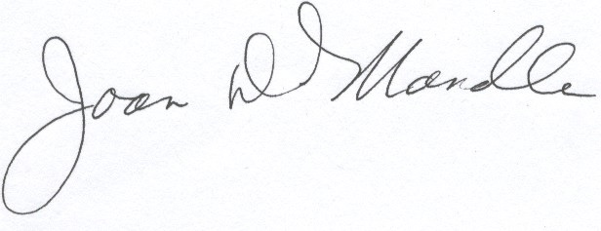
Joan D. Mandle, Ph.D. Executive Director, Democracy Matters 201 Riverview Drive Poughkeepsie NY 12601

