
The League of Women Voters

A Voice for Citizens, A Force for Change

St. Lawrence County

St. Lawrence County Redistricting: Testimony about First Draft Maps

Ever since 2012 St. Lawrence County has been divided into four Assembly and three state Senate districts. Due to these divisions, the interests of SLC are currently a priority for none of our representatives. Only one lives in the county, and we rarely see any of them, even during campaign season. The League of Women Voters of SLC was therefore very pleased to see that both sets of district maps proposed by the IRC now respect the County’s borders.

Compare the current map showing Assembly Districts 115, 116, 117, and 118

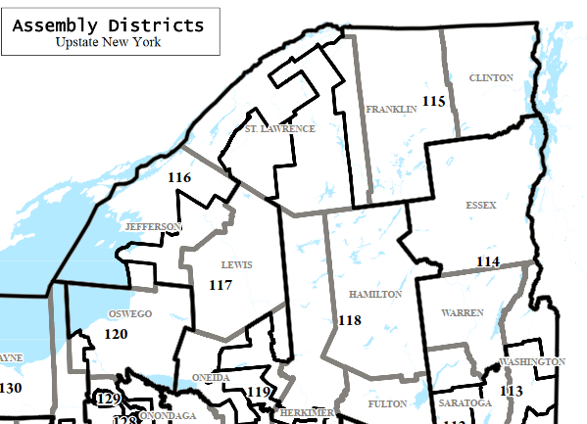

With the proposed “Names” and “Letters” Assembly maps of STLWRNC and AD DN:

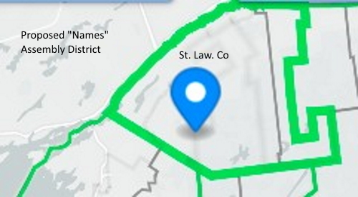

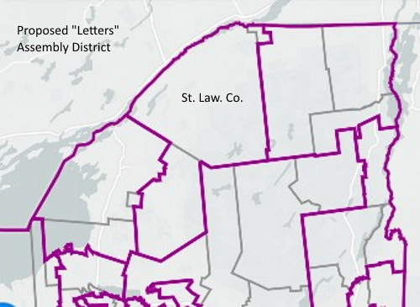

And compare a map of Senate districts: 45, 47 and 48.

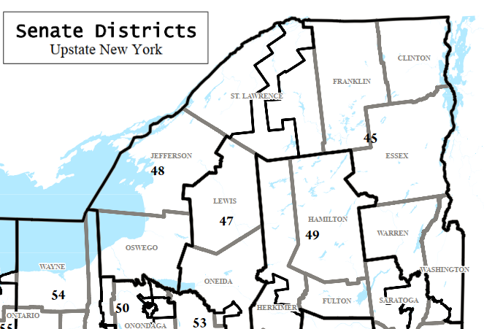

With the proposed IRC versions of NRTHWSTNY and SD BI:

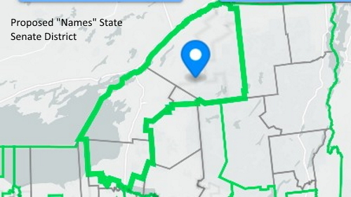

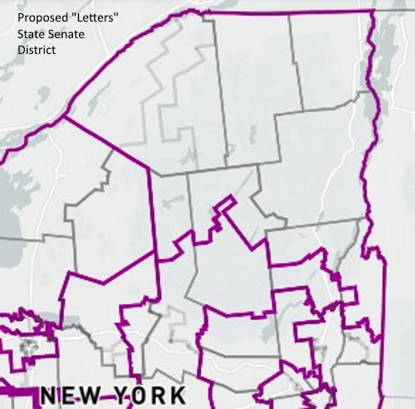

Under either one of these sets of maps, SLC’s single Assembly Member and lone Senator would have reason to pay closer attention to the interests of our two main non-agricultural economic sectors, education and healthcare. (Our leading employers include our 17 school districts and four major universities as well as St. Lawrence Health Systems and United Helpers.)

Currently all but one of our state representatives are Republicans even though voter registration data shows that the county is more evenly split between Republicans, Democrats, unaffiliated voters, and adherents of other parties. If either of these maps were to be approved, candidates seeking to represent SLC would have to address the concerns of a broader swath of the electorate. The League feels strongly that one antidote to the poisonous hyper-partisan political atmosphere currently smothering democratic politics, would be districts that are not drawn solely to create safe seats. Such districts encourage either the uncontested reelection of incumbents, or primary challenges from the political extremes.

The same is true for Congressional districts. St. Lawrence County is currently part of the sprawling District 21 where there has not been a truly competitive election in some time now. The Letters map (Y) would make little change to the boundaries of District 21, whereas the Names map, which divides the northern part of the district (NORTHEAST and JEFFRSNULSTR) might create a situation where candidates would have to appeal to a more politically heterogeneous voting population. The League would welcome any changes that would foster reasoned debate over substantive issues, rather than battles of fund-raising sound-bites.

In our previous testimony, the LWV of St. Lawrence County has noted the problems facing rural New York counties like our own. We have deplored the difficulty of doing advocacy work when concerned citizens are compelled to contact the offices of seven different (and often disinterested) office holders to solicit their support for needed legislation. The proposed new districts would enable citizens to establish a real relationship with our state representatives. Conversely, those representatives would be able to speak with a clearer voice on our behalf in the state Legislature if they can point to a more unified set of interests shared by their constituents.

As happy as we are with the current proposed maps, the LWV SLC is dismayed that we have two sets of them to consider. We expected some hiccups in the new independent redistricting process this first time through, but the current state of affairs makes us fear that the state’s sitting legislators will end up drawing their own districts yet again. Politicians, in effect, will therefore continue to choose their voters, instead of voters choosing candidates to represent them. We ask you to recommit to the fundamental purpose of the Independent Redistricting Commission and work to create one set of revised maps before the next round of public comment.

Sincerely,

Kathleen Stein, President
League of Women Voters of St. Lawrence County
Canton, NY

