Dear New York State Independent Redistricting Commission,
My name is Raj Korpan. I am a resident of Rego Park in Central Queens. I am also the Co-Chair of the Central Queens Redistricting Commission and have lived in Queens for 10 years. Our organization is a non-partisan, community-based group that is focused on keeping Central Queens whole. We participated in the first round of IRC hearings and look forward to continuing to engage with the Commission. I am submitting this testimony to convey our deep concerns with the proposed Draft Assembly Plan for Queens County.
The draft map places me in the Proposed Assembly District 38, which spans from Long Island City in Western Queens, Greenpoint in Brooklyn, through Ridgewood, Maspeth, Glendale, Middle Village, and finally Rego Park in Queens. These communities are vastly different with different types of racial and ethnic compositions, transportation options, types of housing, and do not share places of socializing, recreation, and worship. Furthermore, this district does not contain any of these neighborhoods in their entirety. Instead it splits everyone of those neighborhoods into multiple districts, as shown below in Figure 1. If the goal of redistricting is to keep communities of interest whole, then this district has completely failed to achieve it. It actually actively splits up communities of interest for no apparent reason.
Figure 1: Every neighborhood that the draft AD 38 passes through is NOT kept whole in the district. Each neighborhood is instead split in 2-3 districts, keeping communities of interest separate and unable to elect a representative as a whole.
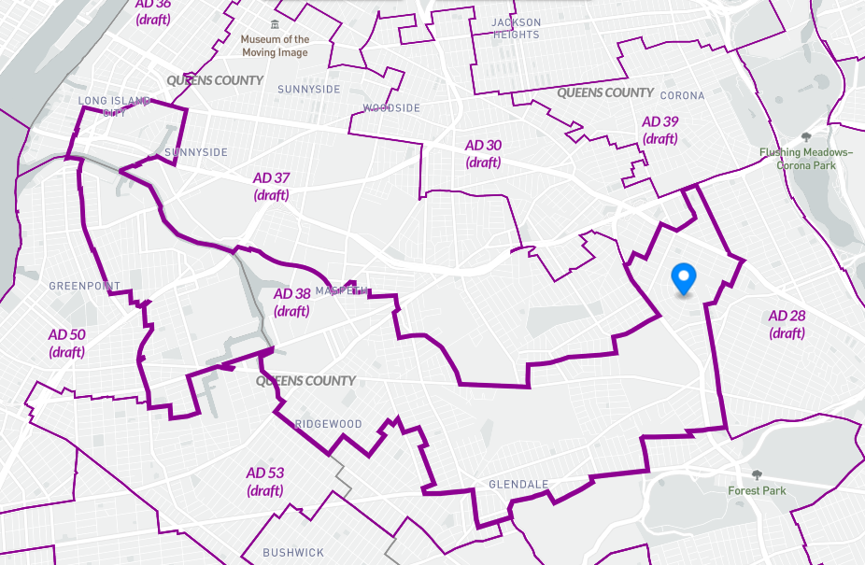

Specifically, my neighborhood of Rego Park has been split into three districts: ADs 38, 28, and 30. Rego Park is a diverse community with a large population of Asian and Jewish people. It is a neighborhood with many families with young children, and a mix of apartment buildings, multi-family homes, and single-family homes. We are centered around Queens Boulevard, where many people shop and eat. As shown in Figure 2 below, the natural boundaries of our neighborhood are Woodhaven Boulevard to the West, the Long Island Expressway to the North, the 108th Street to the East, and Yellowstone Boulevard to the South. Rego Park shares many of its cultural institutions and places of worship with Forest Hills, which, historically, have always been paired together in assembly district 28. We strongly request that Rego Park be kept whole in one district, and that the district groups Rego Park with Forest Hills.
Figure 2: The natural boundaries of Rego Park are the Long Island Expressway in the North, Woodhaven Boulevard to the West, the 108th Street to the East, and Yellowstone Boulevard to the South.
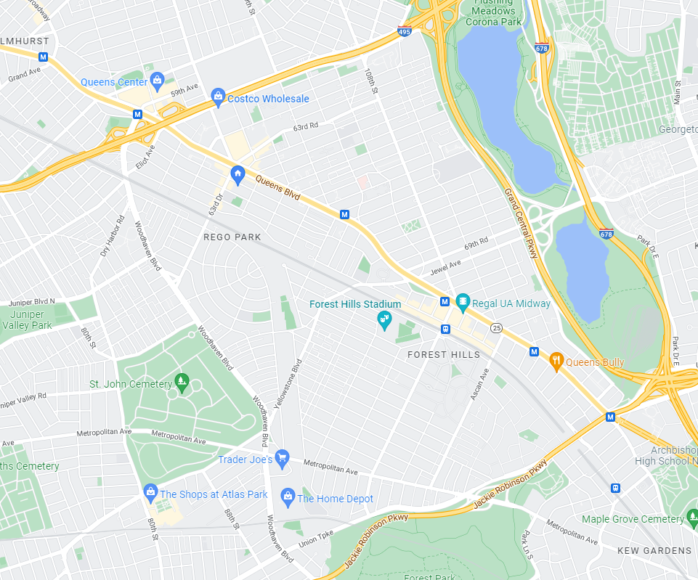

Finally, I would like to strongly suggest that the IRC limit, as much as possible, districts that cross county lines. This is particularly egregious in the draft map for Queens, with 6 districts crossing multiple counties. It should go without saying, but the boroughs of New York City are administered very differently at the local and city level. For example, during the city council redistricting process, many individuals testified against a district that crosses from Queens into Manhattan, and advocated for Roosevelt Island and the east side of Manhattan to be kept in districts wholly in Manhattan. The proposed AD 36 makes this same mistake and should not be formed as shown in the proposed map. Furthermore, AD 53 and 54 should remain entirely in Brooklyn and not take pieces of Ridgewood and Glendale from Queens. AD 35 takes in Rikers Island, and AD 23 takes in islands in Jamaica Bay, but these islands should remain as part of districts in the Bronx and Brooklyn, respectively.
In summary, redistricting should keep communities of interest whole so that they are empowered to elect representatives to advocate for their issues. The proposed Assembly Map violates this principle. AD 38 is particularly an awful district and should not exist in its current form. Other cross borough districts also break up communities and dilute their ability to organize on common interests. Finally, Central Queens is a cohesive community of interest with many shared characteristics. Any new assembly map should endeavor to keep Rego Park whole and in the same district as Forest Hills.
I look forward to sharing this testimony with the IRC at the Queens County Public Hearing and am happy to answer any questions the Commission may have.

Sincerely,
Raj Korpan
Co-Chair of the Central Queens Redistricting Coalition

