Redistricting Testimony, Feb. 7, 2023
Kaye Playhouse, Hunter College
695 Park Avenue
Christine Gorman
West 55th Street Block Association

Good afternoon. My name is Christine Gorman. I live at 345 West 55th Street between Eighth and Ninth Avenues. I have lived in Hell’s Kitchen for more than 30 years. I am the president of the West 55th Street Block Association and a founding member of the Hell’s Kitchen Neighborhood Coalition.
I speak today on behalf of the West 55th Street Block Association in favor of the draft map (12/01/22) for Assembly District 75 with a few adjustments. The northern boundary of AD 75 should run primarily along West 57th Street from Seventh Avenue to the Hudson River, instead of along West 53rd Street in order to preserve the Hell’s Kitchen community of interest. You could make up the population difference by taking away the southeastern corner of the draft map bounded by Sixth Avenue, 26th Street, Park Avenue, East 20th, Irving Place and along East 14th back to Sixth Avenue. As an added bonus, our revision would be more compact and would more closely represent the greater racial/ethnic diversity of our area. Please see the maps on page 3.
The rationale: The current draft map for Assembly District 75 unfairly lops off the northern portion of our historic community of interest—the Hell’s Kitchen neighborhood. Since the 1880s, Hell’s Kitchen has run from West 59th street in the north along Eighth Avenue to the east and across West 34th to the Hudson River. Residents and community leaders have worked for decades to keep Hell’s Kitchen whole at the state level, just as we have with City government.
More than 16,000 residents in the West 50s will be adversely affected by the NYIRC’s draft map because our interests and needs are more closely aligned with our neighbors in the West 30s and 40s of Hell’s Kitchen rather than our neighbors to the north in AD 67 and the Upper West Side.
Nothing against the Upper West Side, but the West 50s are not the Upper West Side. The Upper West Side is Levain Bakery and Fairway’s. We are Amy’s Bread and the Amish Market. We are drag shows at the Rise Bar and the Spot. They are brunch at Sarabeth’s. We straightforwardly call our avenues Eighth, Ninth, Tenth and Eleventh. That’s not fancy enough for the Upper West Side, where those same roads are called, respectively, Central Park West, Columbus, Amsterdam and West End Avenues.
Even though Hell’s Kitchen still claims West 59th street as our northern border, we ask that you run the northern border of AD 75 along West 57th street because it is a large, double-wide commercial cross-street and more of a natural border—unlike either West 59th or West 53rd Streets, which are narrow residential streets.
Running the northern boundary of AD 75 along West 57th also more closely follows the northern boundary of Community Board 4, the Clinton Special zoning District and the Hudson River Park. We need to keep all these political entities in the same Assembly District so that our common interests are not lost in the cracks between ADs.
Similarly, Seventh and Sixth Avenues are more natural eastern boundaries—recognized by residents, tourists and map-makers alike—that keep whole the three main neighborhoods of Assembly District 75—Hell’s Kitchen, the Garment District and Chelsea. The current southeastern corner of AD75 in the draft map extends well past Fifth Avenue over into the East side, around Union Square, which has never been part of AD75 and does not have the same political or community issues we face.
In addition, the natural center of gravity for the West 50s is the Port Authority at West 42nd Street and the Lincoln Tunnel—and we have the traffic jams to prove it. As part of Assembly District 75, we will have a stronger voice and representation negotiating with New York State over common issues that affect all of Hell’s Kitchen—such as a proposed casino at Hudson Yards, renovations at the Port Authority or Lincoln Tunnel.
I have attached a map that shows our proposed AD75 district, which you can find online at https://districtr.org/plan/174706. Our revised AD75 would contain 137,962 people, which varies by 2.44% from the ideal of 134,675—and is just a few hundred people more than the NYIRC draft map (137,138). Our district lines also reflect more closely the greater racial/ethnic diversity of our area. Our proposed map would be 18.3% Hispanic vs 16% NYIRC draft; 17.9% Asian vs. 13% NYIRC draft; 7.4% Black vs 6% NYIRC draft; and 51.6% white compared to 64% in the NYIRC draft.
Once again, we urge you to move the northern border of AD75 further north, to West 57th Street, and to make up the difference by taking away the southeastern corner from your current draft map.
Thank you for your time, hard work and attention.
Sincerely,
Christine Gorman
President
West 55th Street Block Association
345 West 55th Street
New York, NY 10019

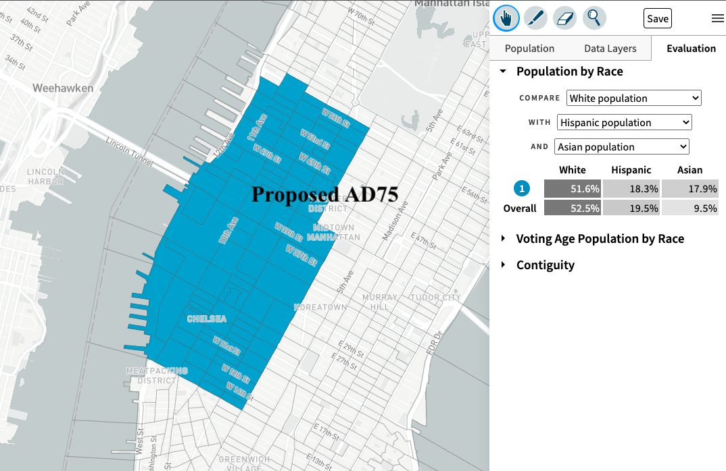
West 55th Street Block Association proposed plan to Keep Hell’s Kitchen Whole
https://districtr.org/plan/174706

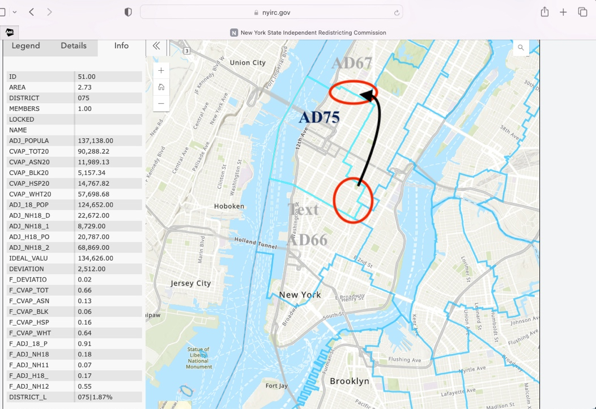
NYIRC Dec. 2022 draft plan
https://www.nyirc.gov/assembly-plan

