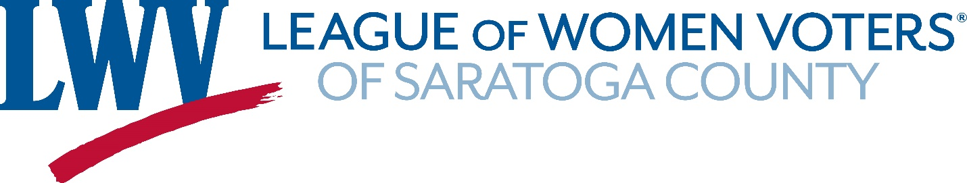

Written Testimony and Map Submission to the IRC
League of Women Voters of Saratoga County, NY
November 16, 2021

Commissioners,
On November 1, the League of Women Voters of Saratoga County testified before the Commission in Albany asking that the new districts be drawn with respect for our municipal and County borders and our position as part of the Capital Region.
When addressing Congressional Districts, you will recall that many of the speakers at SUNY’s Page Hall voiced similar requests. We all know the strength of the ties in the Capital Region which call for unified representation for the five cities of Saratoga Springs, Albany, Troy, Schenectady and Amsterdam and their immediate suburbs. We are one region linked by central highways and regional public transportation. Our black and brown communities share challenges that require common solutions. Medical facilities, university networks and social services also span the Region.
The Commission asked us to draw maps that would demonstrate how a unified, compact Capital District might be drawn. Today we submit a map that accomplishes this goal.
Similarly, the proposed State Senate and Assembly District Maps of the IRC do not reflect the relationships between communities in Saratoga County. As we have previously testified, the county is currently broken into two Congressional districts, two state Senate districts and four state Assembly districts. These excessive divisions dilute and obscure the voice of communities of interest within Saratoga County. It is particularly important that our school districts are not split. Attached are maps for Senate and Assembly districts that avoid divisions such as these wherever possible.
In closing the League of Women Voters of Saratoga County asks the Independent Redistricting Council to carefully consider the maps we have submitted and let the voices you heard in Albany on November 1st guide your understanding of the Capital Region.

Sincerely,

Elizabeth Rossi
Board Member
League of Women Voters of Saratoga County
President@lwvsaratoga.org

