My name is Diana González. I am a resident of Windsor Terrace. I am a member of Community Board 7 and the Vice Chair of CB7’s Environment and Sanitation Committee. I am also the President of the Central Brooklyn Independent Democrats, which has been the Democratic political club of the 44th Assembly District since 1968, and I am the Corresponding Secretary of the 44th Assembly District Democratic Committee. I submit testimony today on behalf of myself and my community, with which I am deeply familiar due to my extensive civic and political engagement. My testimony today relates to the proposed border between the 44th and 51st Assembly districts and the general makeup of the 44th Assembly district, which has been my home for many years.

I’d like to begin by applauding the IRC’s commitment to ensuring that districts are similarly sized. The previous redistricting made the 44th Assembly district oversized relative to other districts, and one of the largest in the state. This requires our representation to cover more ground without increased resources, which is fundamentally unjust. It is my hope that the IRC will continue to prioritize equal population distribution in subsequent draft maps.

Unfortunately, I am also deeply concerned that the IRC has fallen short with regard to several of its legal mandates, namely:
- This draft map results in prohibited denial and abridgement of racial and language voting rights for the Urdu and Bangla speaking South Asian communities of Kensington.
- By splitting the neighborhoods of Windsor Terrace and Kensington between two districts, both the 44th and 51st Assembly districts become significantly less contiguous and compact.
- This draft map fails dramatically at maintaining existing districts, preexisting political subdivisions, and communities of interest in Windsor Terrace and Kensington.

As you can see from the maps at the end of this document (also viewable at https://www.google.com/maps/d/u/0/edit?mid=1uCHIXBavZLLY0FXMn5C8nYUM9y__SoM&usp=sharing), the IRC’s proposal puts the dividing line between the 44th (outlined in green) and 51st (outlined in red) Assembly districts along the Prospect Expressway and then Dahill Road. These major roads bisect the neighborhoods of Windsor Terrace (colored purple) and Kensington (colored orange). Perhaps the IRC thought these roads constitute neighborhood or community dividing lines – in fact, they do not. Dahill is a residential street much like those to the east and west. The Prospect Expressway can be traversed by vehicle or by foot on 7th Avenue, Prospect Park West, 11th Avenue, Seeley Street, and Fort Hamilton Parkway/Ocean Avenue, and has pedestrian bridges at 8th Avenue, 10th Avenue, and Greenwood Avenue, making it incredibly easy for to traverse the expressway. In addition, the Fort Hamilton Parkway subway station, which is underneath the Prospect Expressway, and has entrances on each side of the expressway. Under the proposed lines, this station would be in two districts.

The 44th and 51st Assembly districts are quite different in terms of both demographics and major issues of concern. The 44th District, both historically and under the IRC’s proposed lines, is an affluent, majority non-Hispanic white district. The 51st, both historically and under the IRC’s proposed lines, is a plurality Latiné district with a significant Chinese-American population, and contains a sizable population of public housing residents in Red Hook. Sunset Park and Red Hook share concerns related to their proximity to the waterfront, and the working-class communities in these neighborhoods share similar economic and quality of life concerns as well. In addition, both the Hispanic and Chinese-American communities have specific concerns and needs.

Windsor Terrace is an isolated community of interest. With Prospect Park on one side and Greenwood Cemetery on the other, the only adjacent neighborhoods that are easily accessible are Kensington and Park Slope, the latter of which is demographically quite similar. Greenwood Cemetery is particularly impenetrable: It is surrounded by a high fence, and the only entrance that is routinely open is the entrance on 5th Avenue in Sunset Park. It cannot be traversed. In addition, there is no direct mass transit connection between Windsor Terrace and Sunset Park, a point that was recently raised at the hearings on the Brooklyn bus route redesign.

To illustrate Windsor Terrace’s geography, I need only look at my own history. Over my time living in Windsor Terrace, I have lived at four addresses: On 16th Street, Prospect Park West, East 5th Street, and East 4th Street. At all of these addresses, I used the same subway line and bus routes, shopped at the same grocery store, pharmacy, and green market, had my hair styled at the same salon, patronized the same bars and restaurants. I was always part of the same community. Under the proposed lines, two of these addresses would be in the 51st Assembly district, while two would remain in the 44th district.

Similarly, Kensington is a unique community of interest. As a largely south Asian immigrant community and home to the area known as Little Pakistan, it is culturally distinct from all of the neighborhoods that surround it, and care should be taken not to conflate the south Asian community of Kensington with the East Asian community of Sunset Park. Cutting the community in half along Dahill Road does an enormous disservice to the immigrant communities here, who frequent the same houses of worship, community organizations, and small businesses. Given the myriad of languages spoken in Kensington (aside from English, the most common are Urdu and Bangla), it would be impossible for two Assemblymembers to adequately serve non-English speaking residents. Should the IRC insist on splitting Kensington into two districts, there is strong potential for a lawsuit to overturn the district lines on the grounds that this constitutes “cracking.”

Windsor Terrace and Kensington have been kept whole and maintained in the same Assembly district for the last fifty years, if not more. They have been in the same district as Park Slope for thirty years. The tradition of these neighborhoods collaborating on advocacy issues is not one that should be taken lightly – many of our community advocacy organizations are built around these traditional political boundaries. In addition, Kensington, Windsor Terrace, and Park Slope are connected by the F and G subway lines and several bus lines. They share a number of important institutions – for example, Windsor Terrace and Kensington residents go to Methodist Hospital in Park Slope, and Windsor Terrace and Park Slope residents share proximity to Prospect Park.

Should these lines stand, putting parts of Windsor Terrace and Kensington into a district that is dominated by the waterfront communities of Sunset Park and Red Hook, these areas will undoubtedly be underserved by their representation. They will have difficulty accessing a district office in order to receive assistance due to the absence of any direct public transit routes, they will have difficulty gaining attention for local concerns since they would need to petition two Assembly members instead of one.

But the IRC’s proposed lines will do more than split neighborhoods and demographically-like communities:
- They will split transit users: Park Slope, Windsor Terrace, and Kensington all rely on the F/G line. The Fort Hamilton Parkway subway station would itself be split between the two districts, which, given that the MTA is a state agency, would be a jurisdictional problem for the two Assembly members. Residents on both sides of the proposed district border use the B67, B68, and B69 buses, all of which run from Ditmas Park and Prospect Park South through Kensington, Windsor Terrace, and Park Slope. The current draft of the proposed Brooklyn bus redesign maintains these transportation corridors.
- They will split school communities (denoted on the attached map with blue pushpins: The giant pre-K complex at 19th Street and Prospect Park West, which serves many children from Windsor Terrace and Park Slope, would now be in the 51st district. The elementary schools PS 130, PS 154, PS 179, and PS 230 would also be split, as would the junior high school zones. In addition, the Windsor Terrace Public Library would no longer be in the same district as most of the Windsor Terrace and Kensington residents who use it (denoted with a green pushpin).
- They would split religious communities, only a handful of which are named here (denoted on the attached map with red pushpins): The Holy Name of Jesus and Immaculate Heart of Mary Catholic churches would see their communities split between two districts, as would the Flatbush & Shaare Torah Jewish Center. Two prominent Muslim institutions, the Baitul Jannah Zame Masjid and Muslim Community Center and the Bangladeshi Muslim Community Center, would also see their communities split between two districts.
- They would split the communities that frequent local commercial corridors: The Muslim community that is drawn into the 51st district would now be represented by a different Assemblymember than the businesses of the Little Pakistan corridor on Coney Island Avenue, and the Windsor Terrace residents on the western side of the Prospect Expressway would no longer have the same representation as the business corridors they frequent along Prospect Avenue and Prospect Park West, or the grocery store and pharmacy on 10th Avenue and Prospect Avenue. Conversely, the Windsor Terrace residents on the eastern side of the expressway would no longer be in the same district as the businesses on Fort Hamilton Parkway.

Furthermore, these proposed district lines divide communities that share many advocacy concerns:
- The Prospect Expressway and Ocean Parkway are, unlike most roads, under state jurisdiction. Both of them are a source of significant air pollution, noise, and traffic safety concerns. As a member of Community Board 7’s Transportation Committee, I frequently hear residents along the Prospect Expressway voice concerns for street safety along all of the routes where vehicles enter and exit the expressway, including East 5th Street (which would be in the 51st), Seeley Street (which would be in both districts), 19th Street and 11th Avenue (a particularly dangerous intersection and the location of a playground, which would be in the 51st), and 18th Street (which would be in the 44th). It is absolutely essential that the communities around the Expressway and Ocean Parkway have a single representative in order to ensure that the safety and quality of life issues that continually arise from the Prospect Expressway and Ocean Parkway are sufficiently addressed.
- The aforementioned grocery store on 10th Avenue and Prospect Avenue is the only full-sized grocery store in Windsor Terrace and an anchor to the entire community. It was saved from complete removal by a long and determined advocacy from the entire community, on both sides of the expressway. Dividing this community into two districts will make it easier for the store to be shut down, which would leave Windsor Terrace without a single full-sized grocery store.
- As maintenance on the Brooklyn Queens Expressway continues, community members on both sides of the Expressway and Ocean Parkway, from both Windsor Terrace and Kensington, have united to voice concerns about a proposed significant increase of truck traffic in these neighborhoods. This is an issue of ongoing concern and active community participation.

In short, I call on the IRC to revise the border between the 44th and 51st Assembly districts so that it follows the edge of Greenwood Cemetery: 20th Street to MacDonald Avenue to Fort Hamilton Parkway to 39th Street and then east to Dahill Rd. This line is denoted on the attached map in blue.

Map of the Proposed Border Between the 44th and 51st Assembly Districts

Key:
Proposed 44th Assembly District
Proposed 51st Assembly District
Recommended border between the 44th and 51st Assembly Districts

Public schools whose communities would be split between the two districts

Public library whose community would be split between two districts

Houses of worship whose communities would be split between two districts

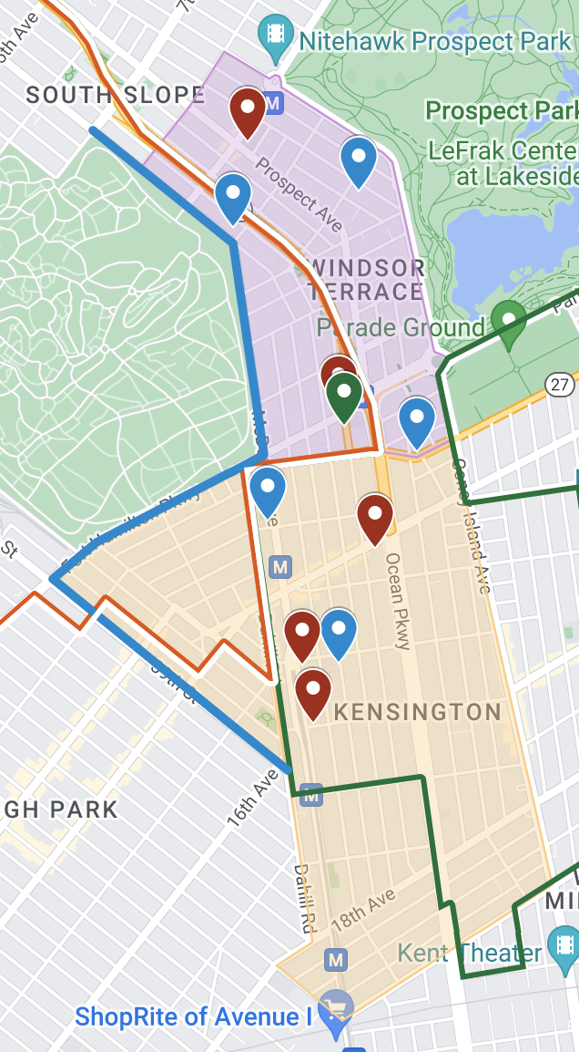
Close Up of Windsor Terrace

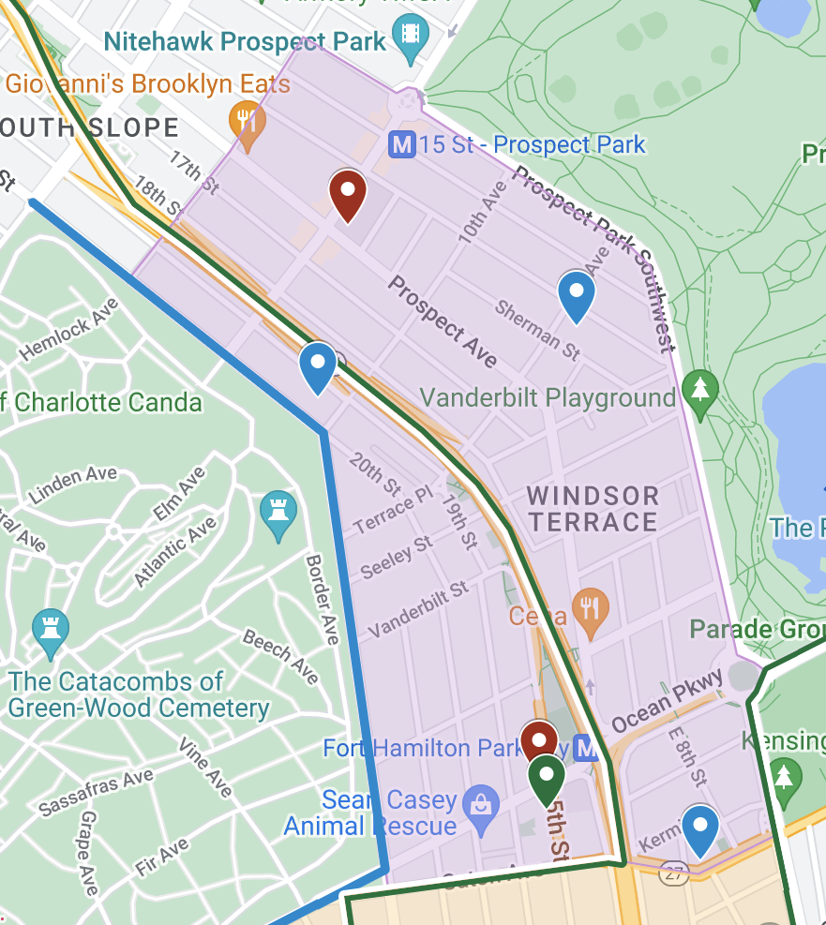

Close Up of Kensington

